Cap18 Validation

Table of contents

Example 2 - Six Column Bent (Back Span) 3

Back Span 3

Forward Span 3

Cap 18 5

SRV 5

Dead Load Results (SRV) 5

Envelopes of Maximum Values (SRV) 7

Maximum Support Reactions (SRV) 8

STR 9

Envelopes of Maximum Values (STR) 9

Maximum Support Reactions (STR) 10

Larsa Results 11

SRV 11

Dead Load Results (SRV) 11

Envelopes of Maximum Values (SRV) 13

Maximum Support Reactions (SRV) 14

STR 15

Envelopes of Maximum Values (STR) 15

Maximum Support Reactions (STR) 16

Comparison 17

SRV 18

Dead Load Results (SRV) 18

Envelopes of Maximum Values (SRV) 20

Live Load Comparison (SRV) 24

Maximum Support Reactions (SRV) 26

STR 27

Envelopes of Maximum Values (STR) 27

Live Load Comparison (STR) 31

Maximum Support Reactions (STR) 33

# Example 2 - Six Column Bent (Back Span)

Example 2 was run for both Larsa and Cap18. Example 2 needed two separate runs to effectively analyze for the backspan and the forward span. This is the analysis of the back span part of the example. Below is a short summary of the bent details.

Bent Details:

* 9 Tx54 backspan girders
* 10 Tx54 forwardspan girders
* 78’ wide bent
* 6 columns spaced at 14’

## Back Span

The figure below shows the beam spacing for the backspan girders. Since Cap18 works in half-foot increments, the beam spacing was rounded to the nearest increments. Both Cap18 and Larsa have the same spacing for the beams.

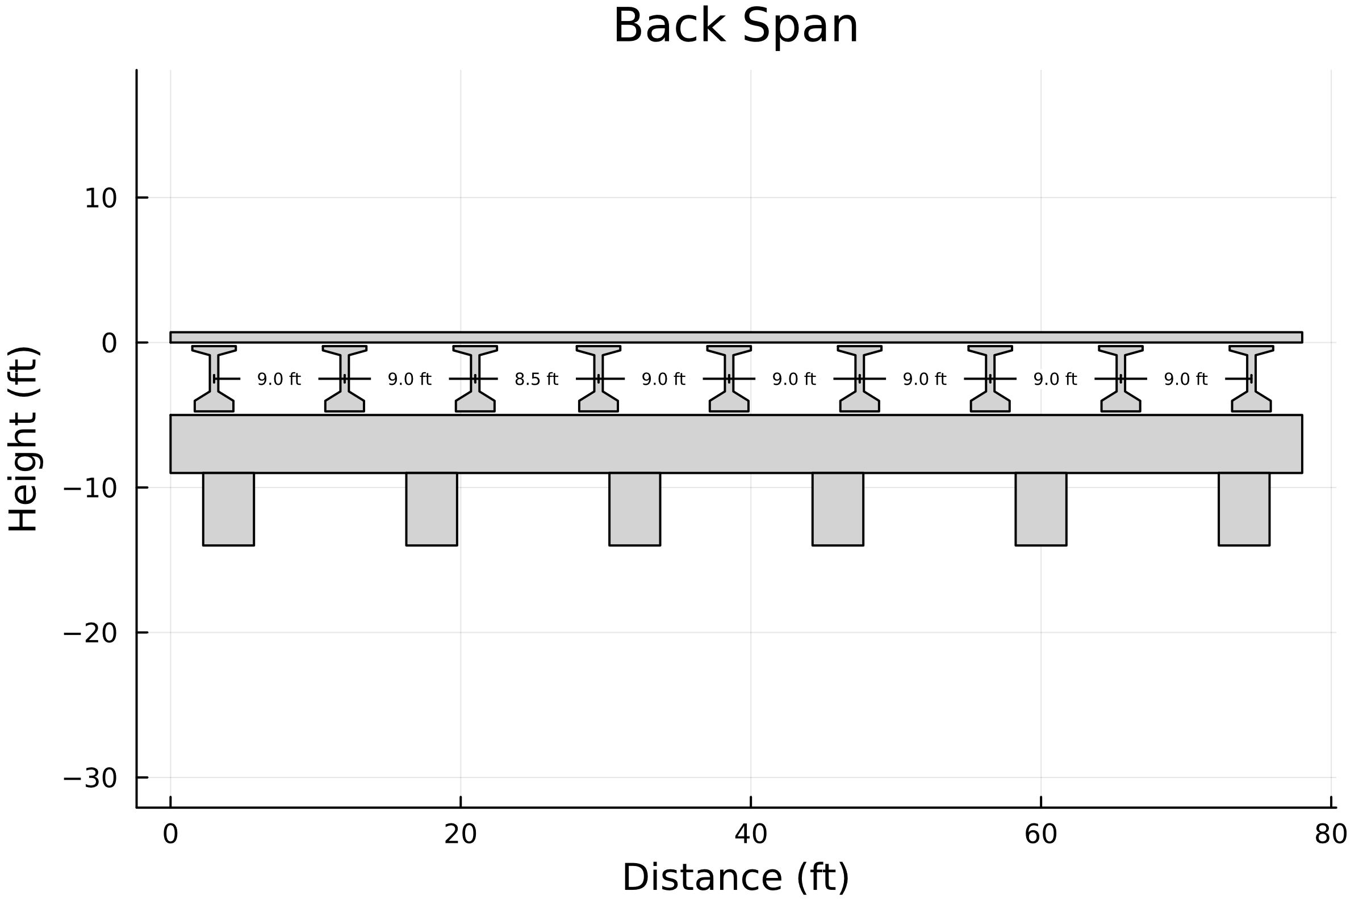

1. Section View of Back Span

## Forward Span

The figure below shows the beam spacing for the forwardspan girders.

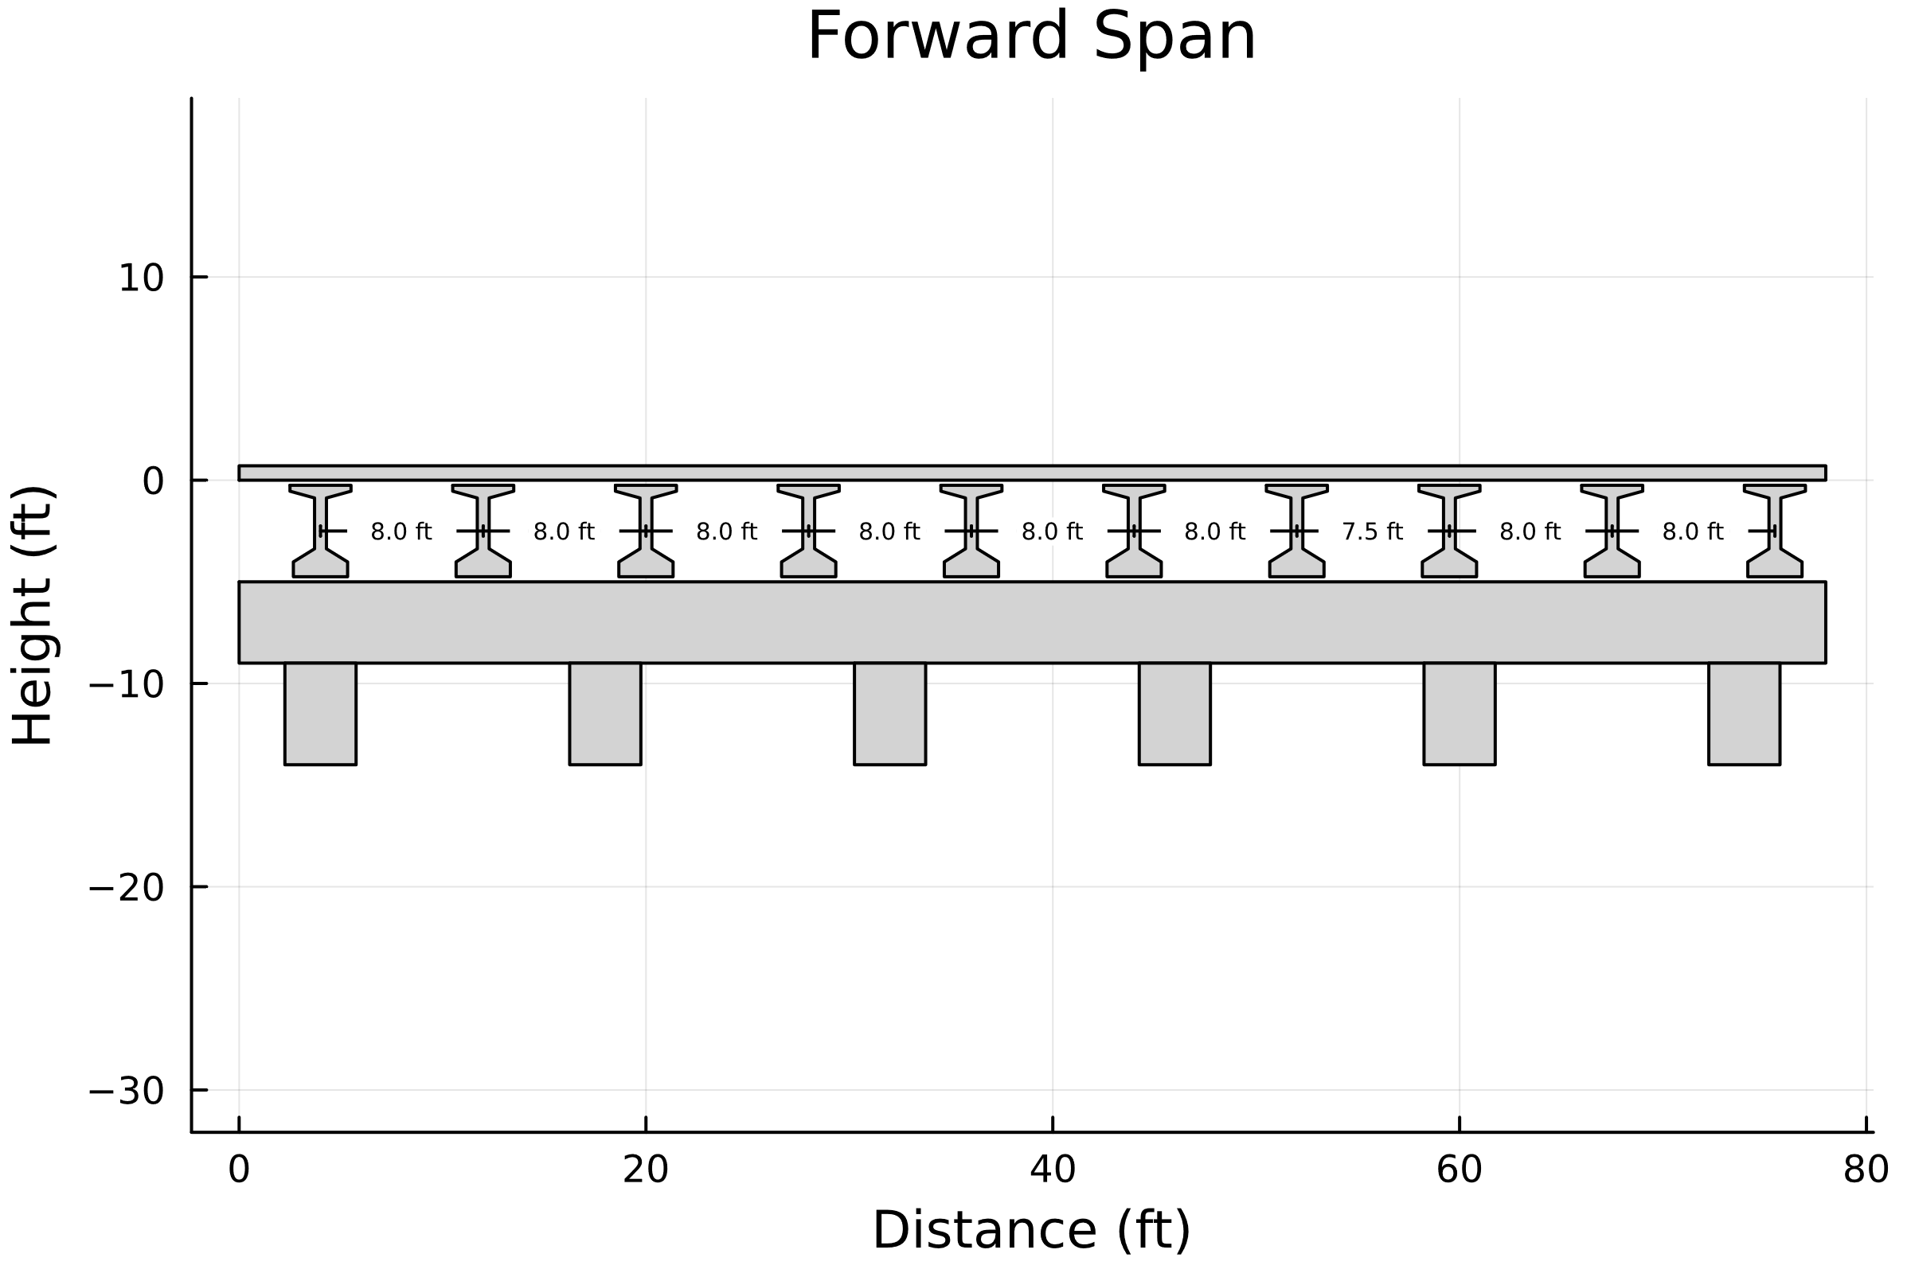

1. Section View of Forward Span

# Cap 18

A Cap18 input file was created and ran for the above bent. The output file was then parsed for the dead load, working stress, and load factor cases. The summary of the findings are discussed below.

## SRV

### Dead Load Results (SRV)

The dead load results were plotted on top of the bent to get a better visual understanding of the results. Based on the DL shear and moment diagrams below, the Cap18 results look to align well with the bent. Sharp changes in shear happen in areas with either a column or a beam, and negative moments are maximized over the columns. This indicates to some degree that the expected behavior of the stresses within the cap is being captured by the Cap18 program. A more detailed comparison with Larsa results will help determine if the magnitudes of these stresses are correct.

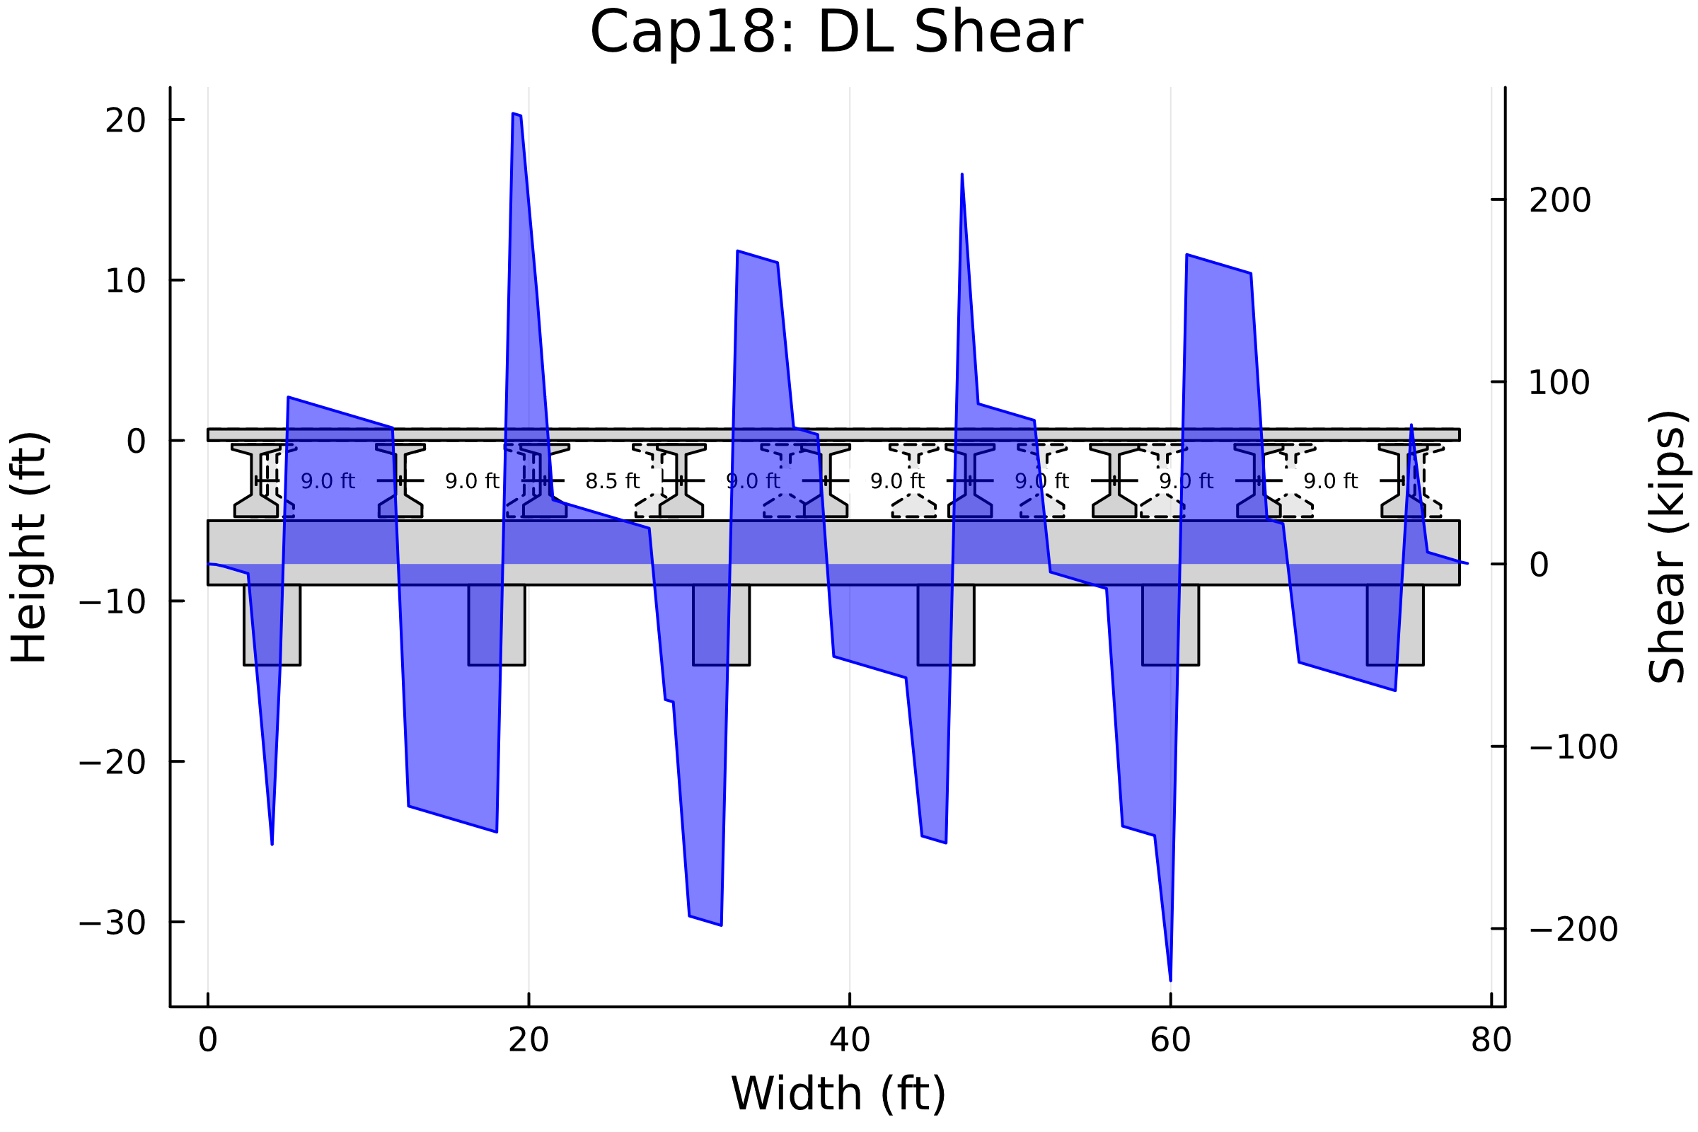

1. Cap18: DL Shear Diagram

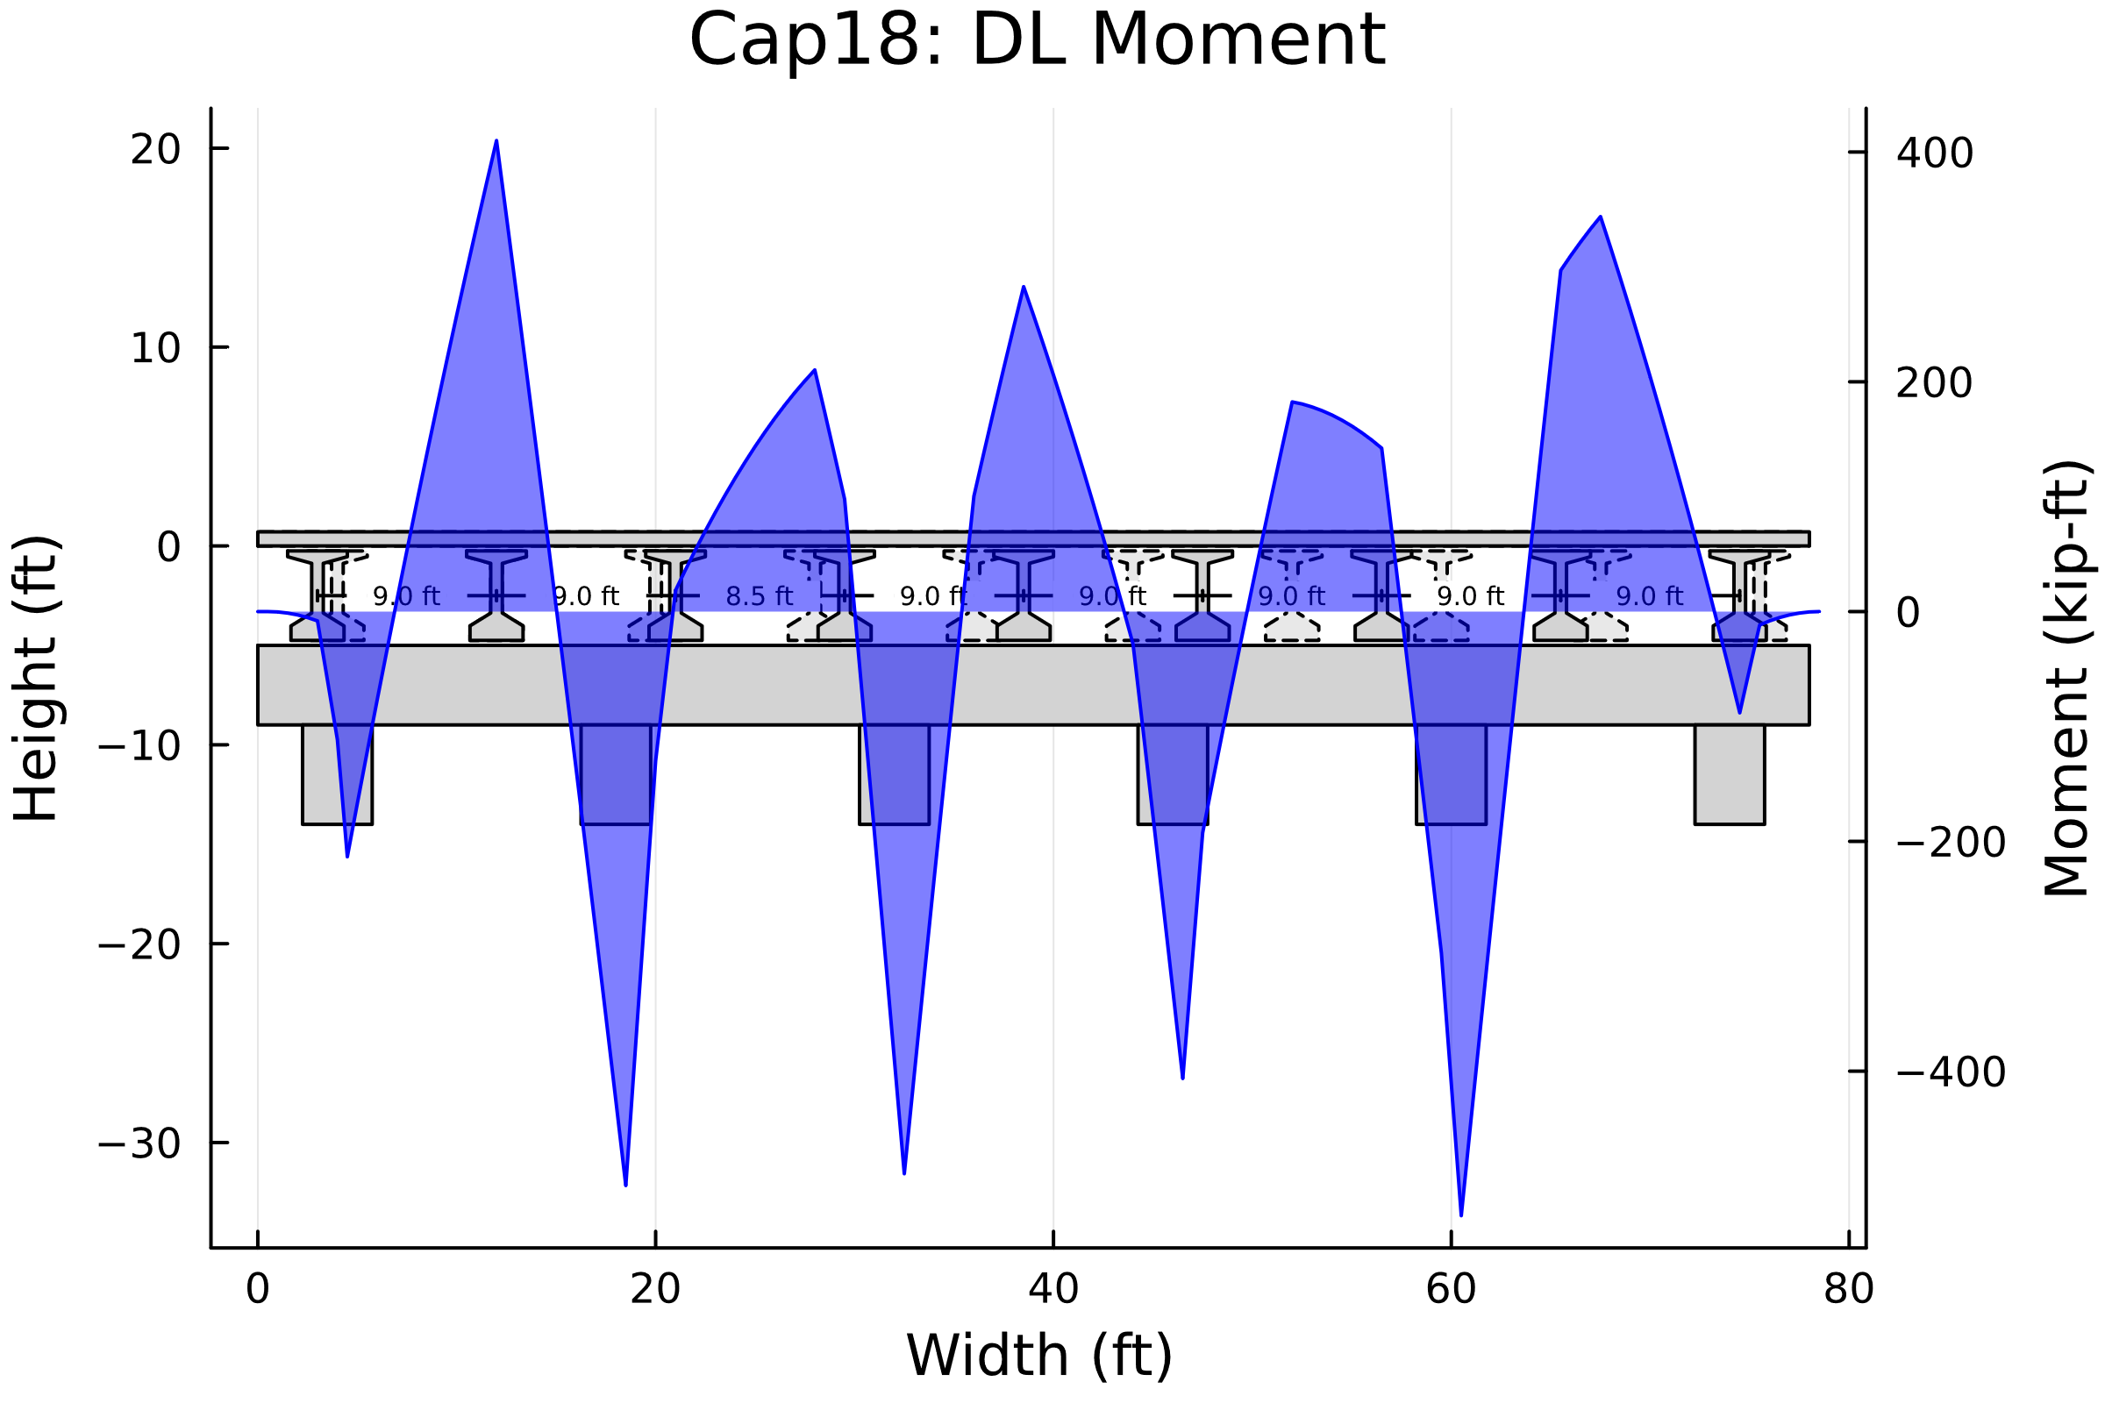

1. Cap18: DL Moment Diagram

### Envelopes of Maximum Values (SRV)

The working stress results were plotted on top of the bent to get a better visual understanding of the results. The results can be seen in the figures below. These stresses follow the same expected behavoir as the DL stresses. Further comparison with Larsa is needed.

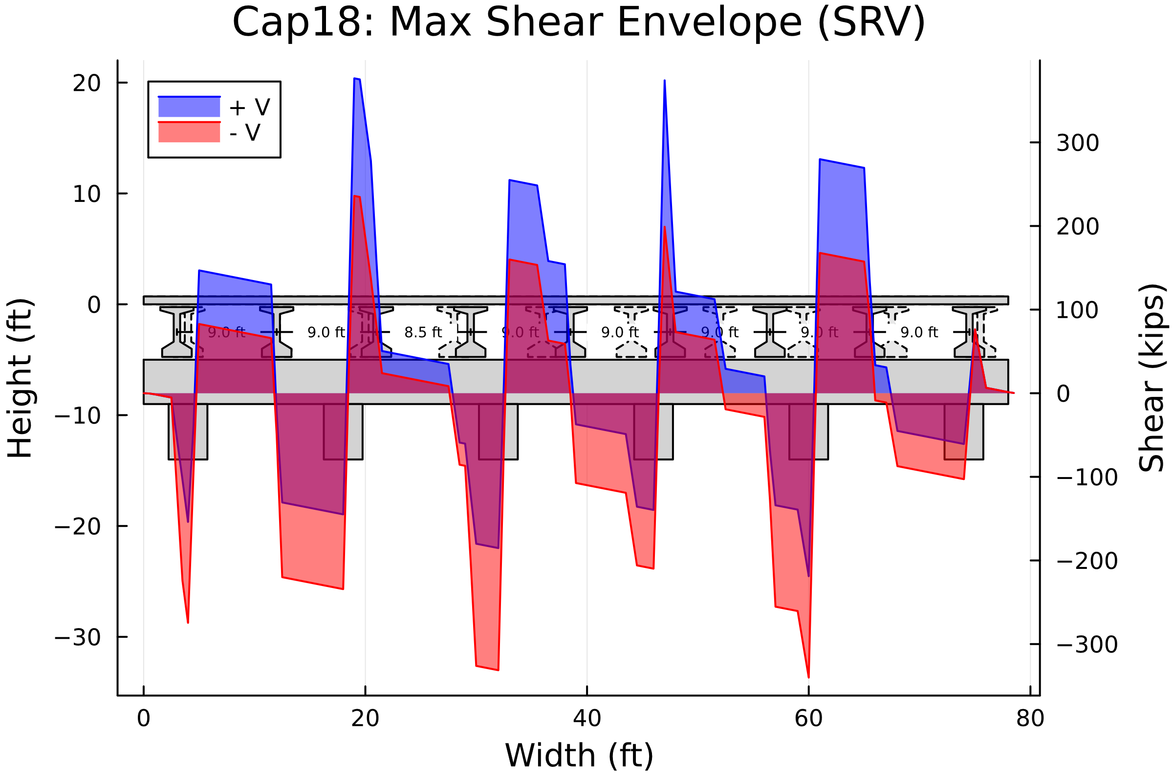

1. Cap18: Service Shear Envelope Diagram

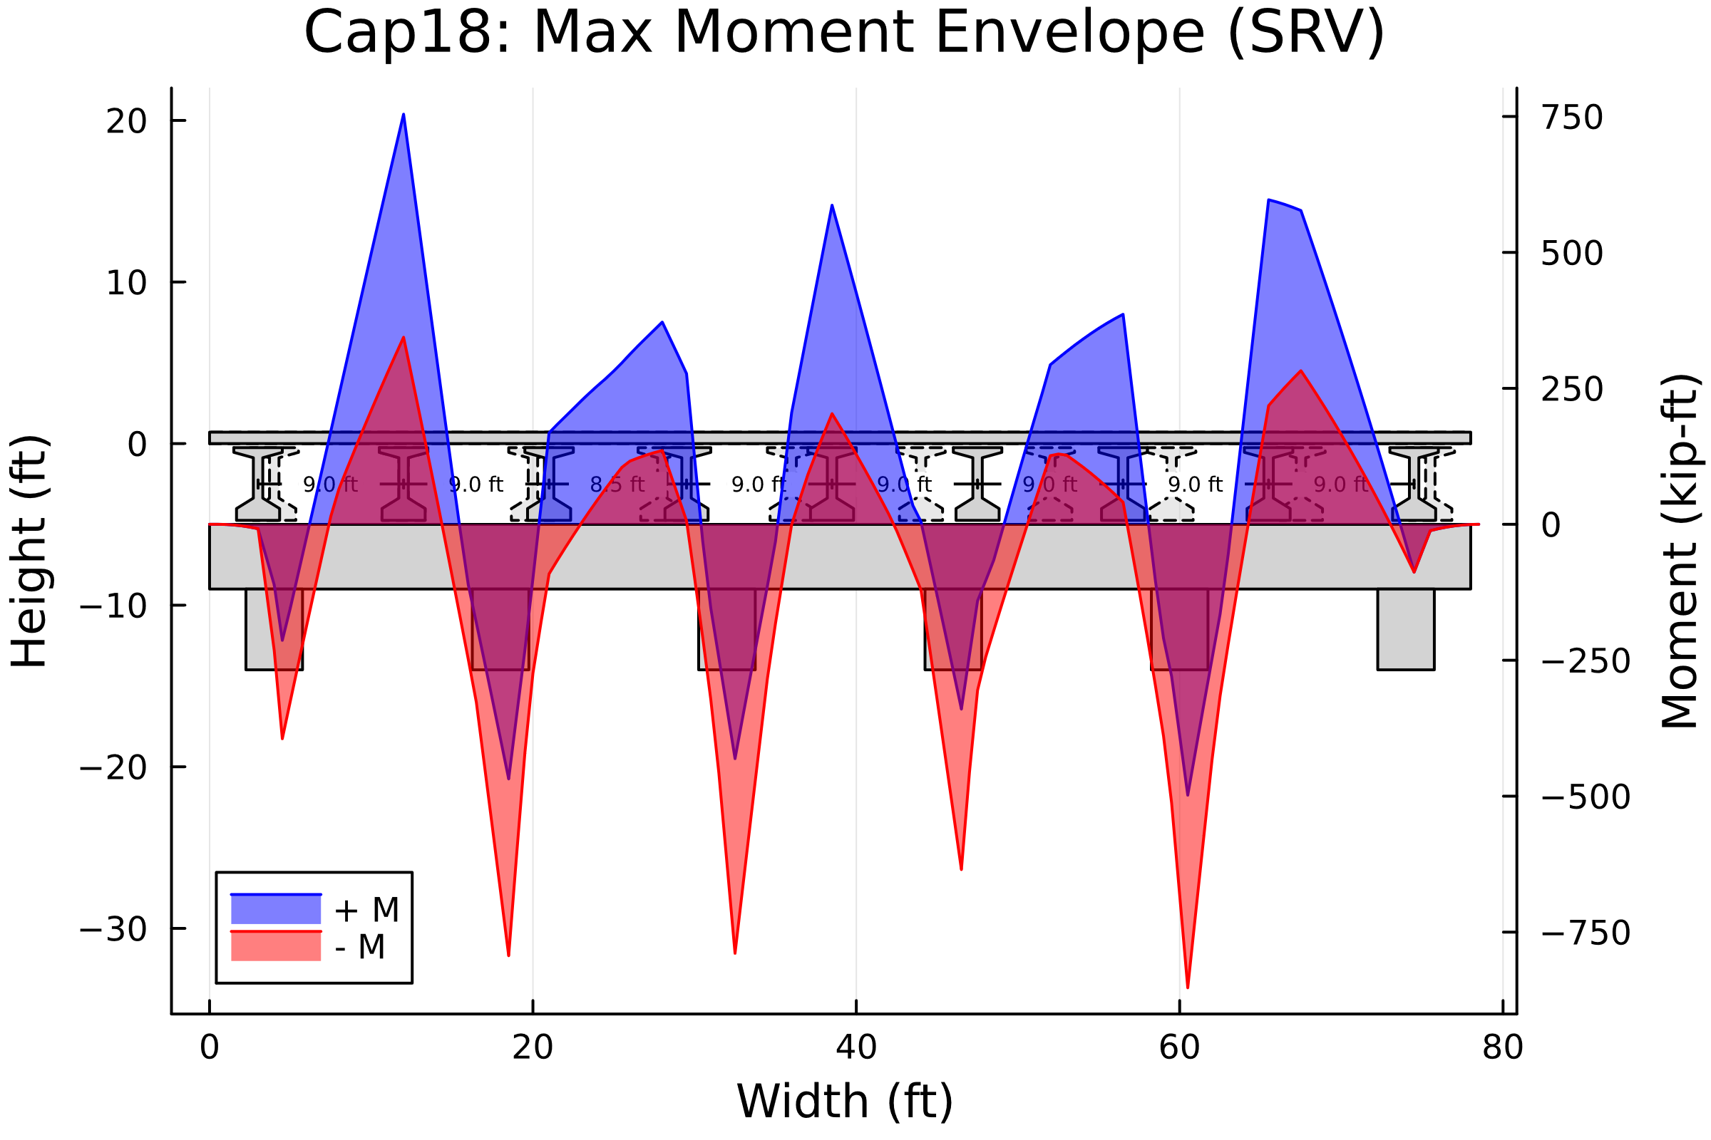

1. Cap18: Service Moment Envelope Diagram

### Maximum Support Reactions (SRV)

The maximum and minimum support reactions for the working stress case are listed in the table below.

1. Cap18: Service Reactions

| Station | Distance | Max Reactions | Min Reactions |
| --- | --- | --- | --- |
| 9 | 4.5 ft | 465.3 kip | 288.4 kip |
| 37 | 18.5 ft | 613.5 kip | 383.5 kip |
| 65 | 32.5 ft | 587.7 kip | 347.7 kip |
| 93 | 46.5 ft | 585.6 kip | 341.3 kip |
| 121 | 60.5 ft | 622.6 kip | 389.2 kip |
| 149 | 74.5 ft | 427.3 kip | 267.5 kip |

## STR

### Envelopes of Maximum Values (STR)

The load factor results were plotted on top of the bent to get a better visual understanding of the results. The results can be seen in the figures below. These stresses follow the same expected behavoir as the DL stresses. Further comparison with Larsa is needed.

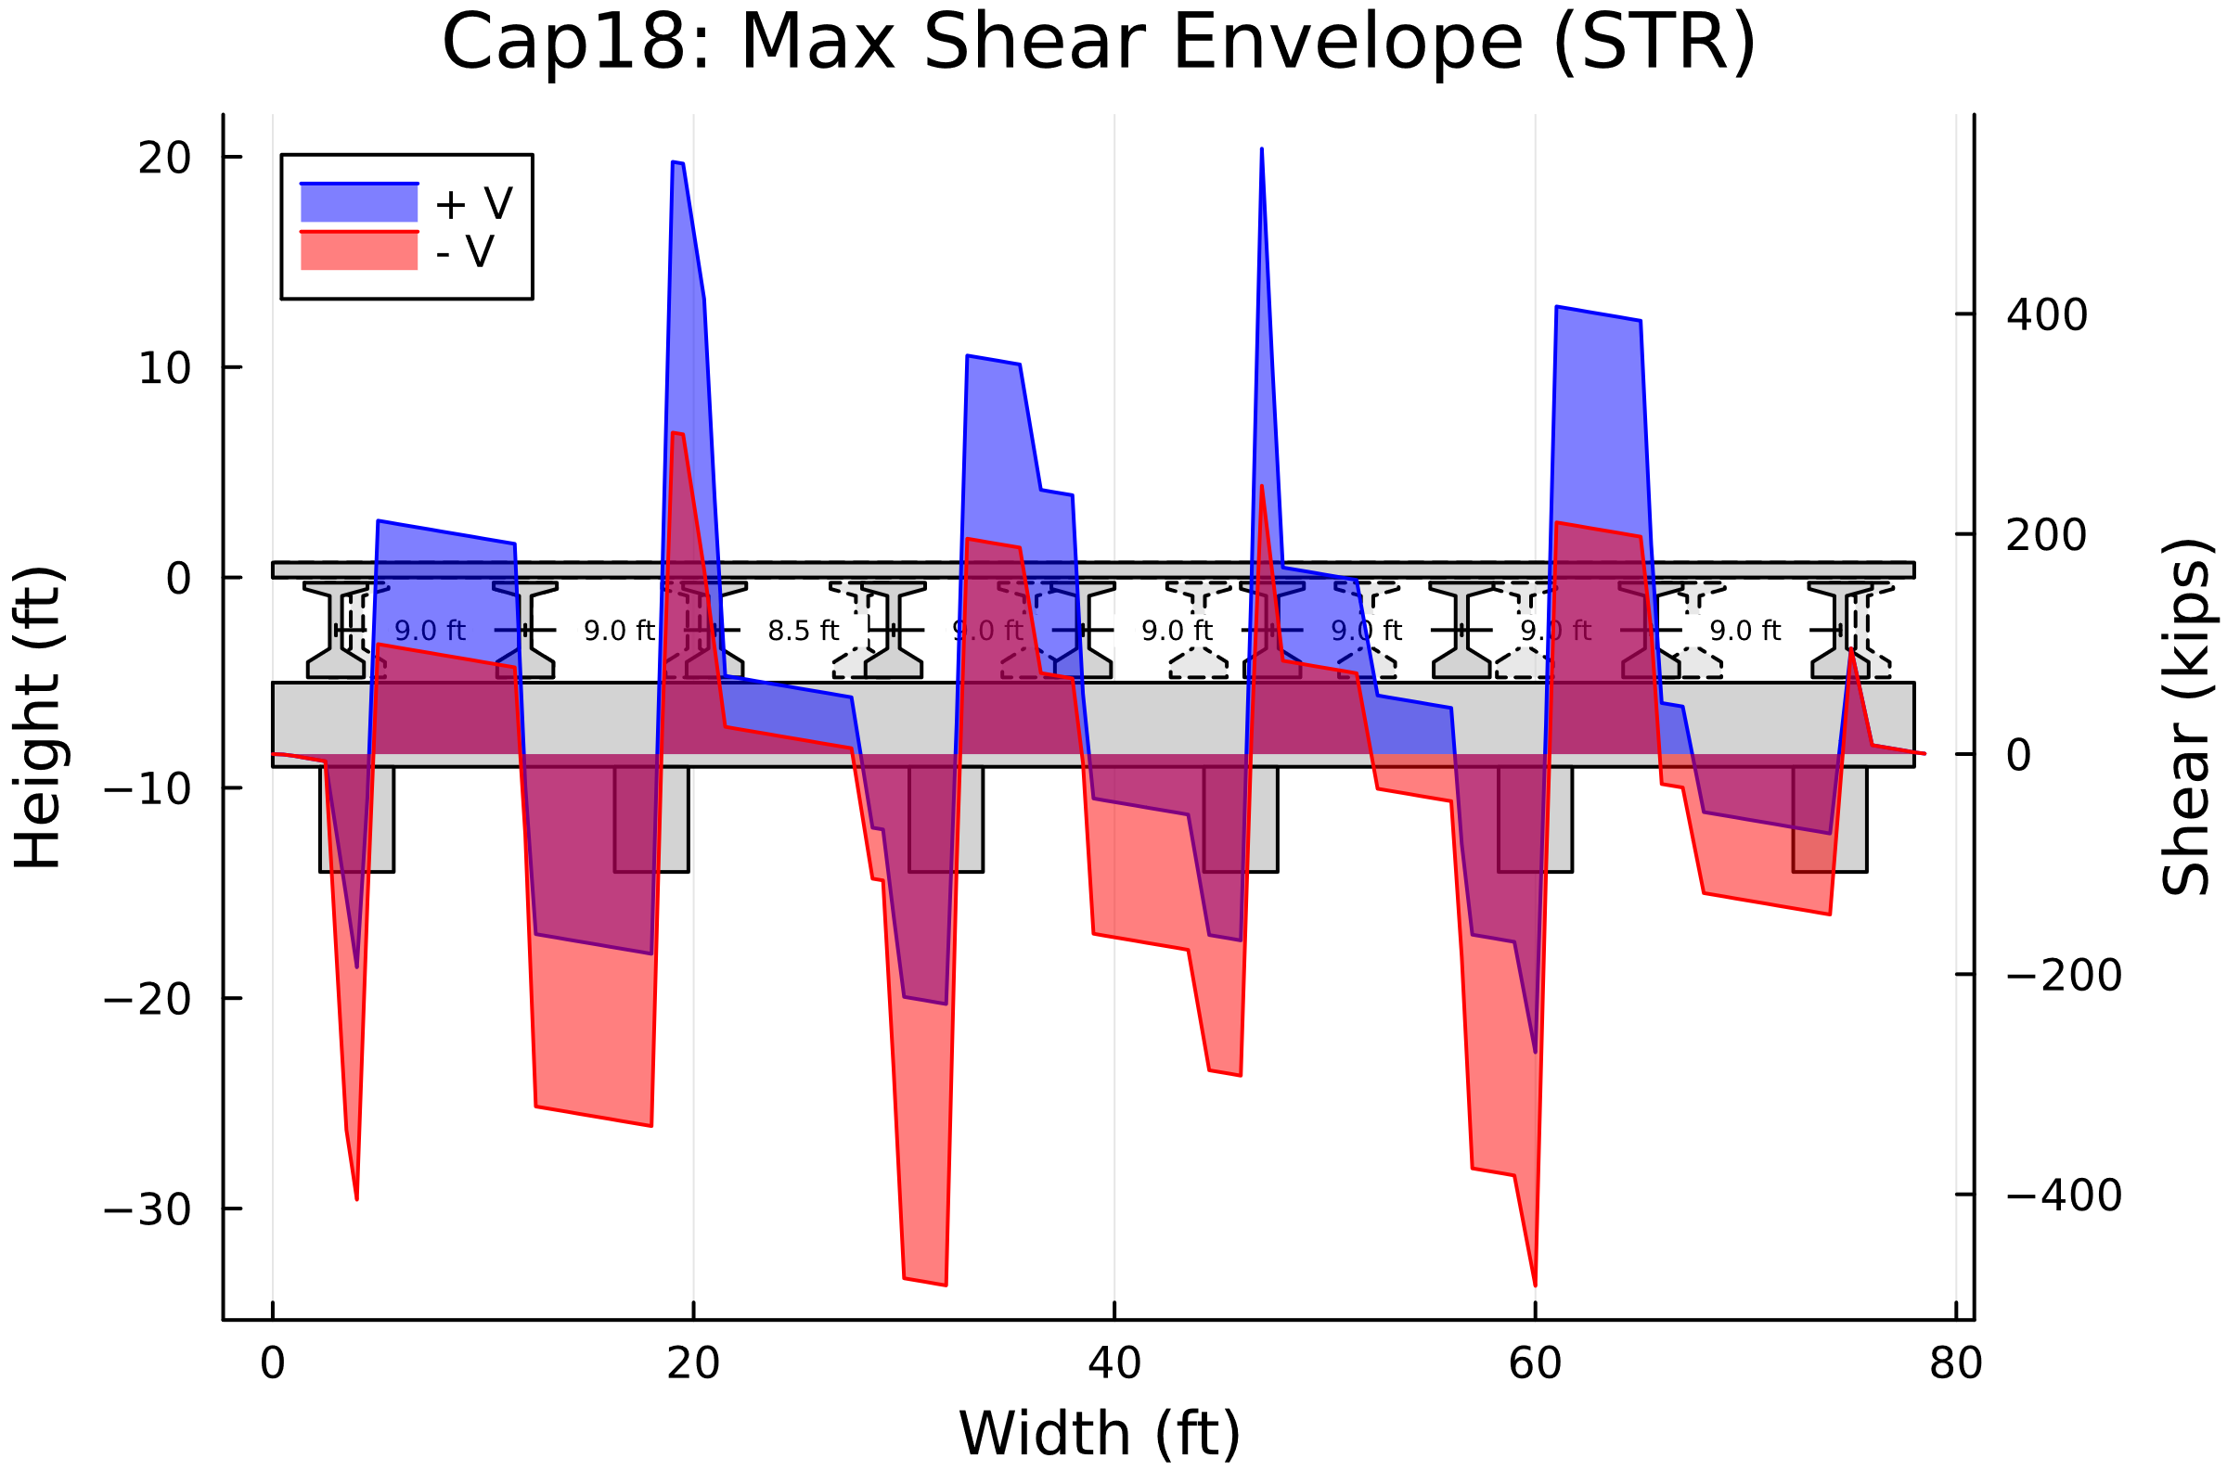

1. Cap18: Strength Shear Envelope Diagram

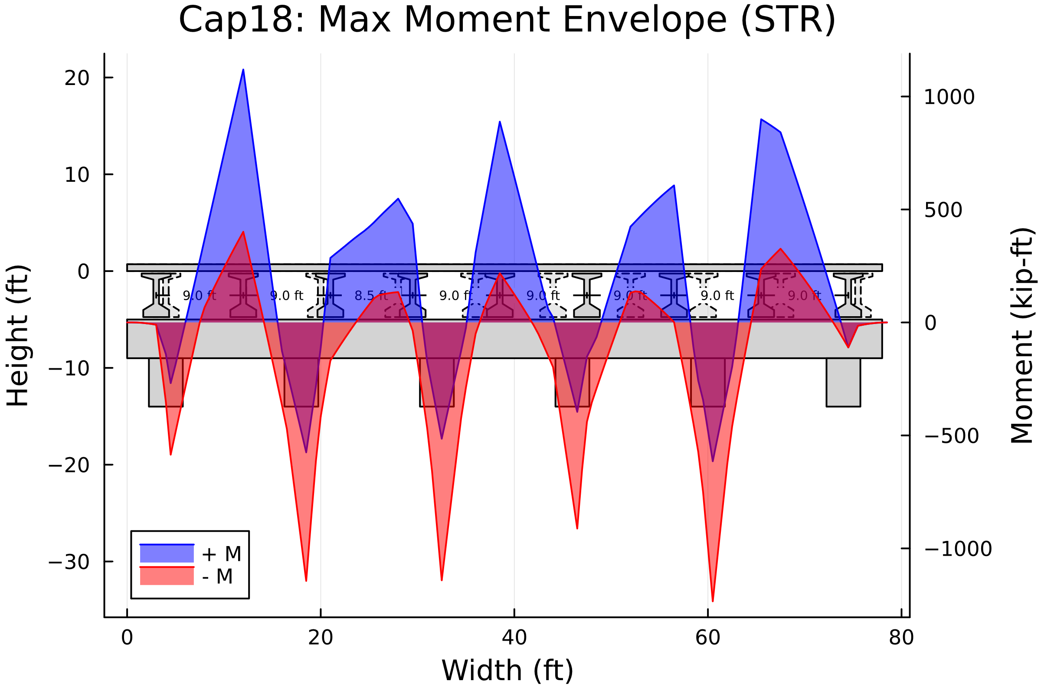

1. Cap18: Strength Moment Envelope Diagram

### Maximum Support Reactions (STR)

The maximum and minimum support reactions for the load factor case are listed in the table below.

1. Cap18: Strength Reactions

| Station | Distance | Max Reactions | Min Reactions |
| --- | --- | --- | --- |
| 9 | 4.5 ft | 668.3 kip | 358.8 kip |
| 37 | 18.5 ft | 879.4 kip | 476.8 kip |
| 65 | 32.5 ft | 846.0 kip | 426.0 kip |
| 93 | 46.5 ft | 843.7 kip | 416.3 kip |
| 121 | 60.5 ft | 893.2 kip | 484.7 kip |
| 149 | 74.5 ft | 612.1 kip | 332.4 kip |

# Larsa Results

A Larsa model was created and ran for the above bent. The loads were extracted for the dead load, working stress, and load factor cases. The summary of the findings are discussed below.

## SRV

### Dead Load Results (SRV)

The dead load results were plotted on top of the bent to get a better visual understanding of the results. Based on the DL shear and moment diagrams below, the Larsa results look to align well with the bent. A more detailed comparison with the Cap18 results will help determine if the magnitudes of the stresses calculated from the Cap18 program are correct.

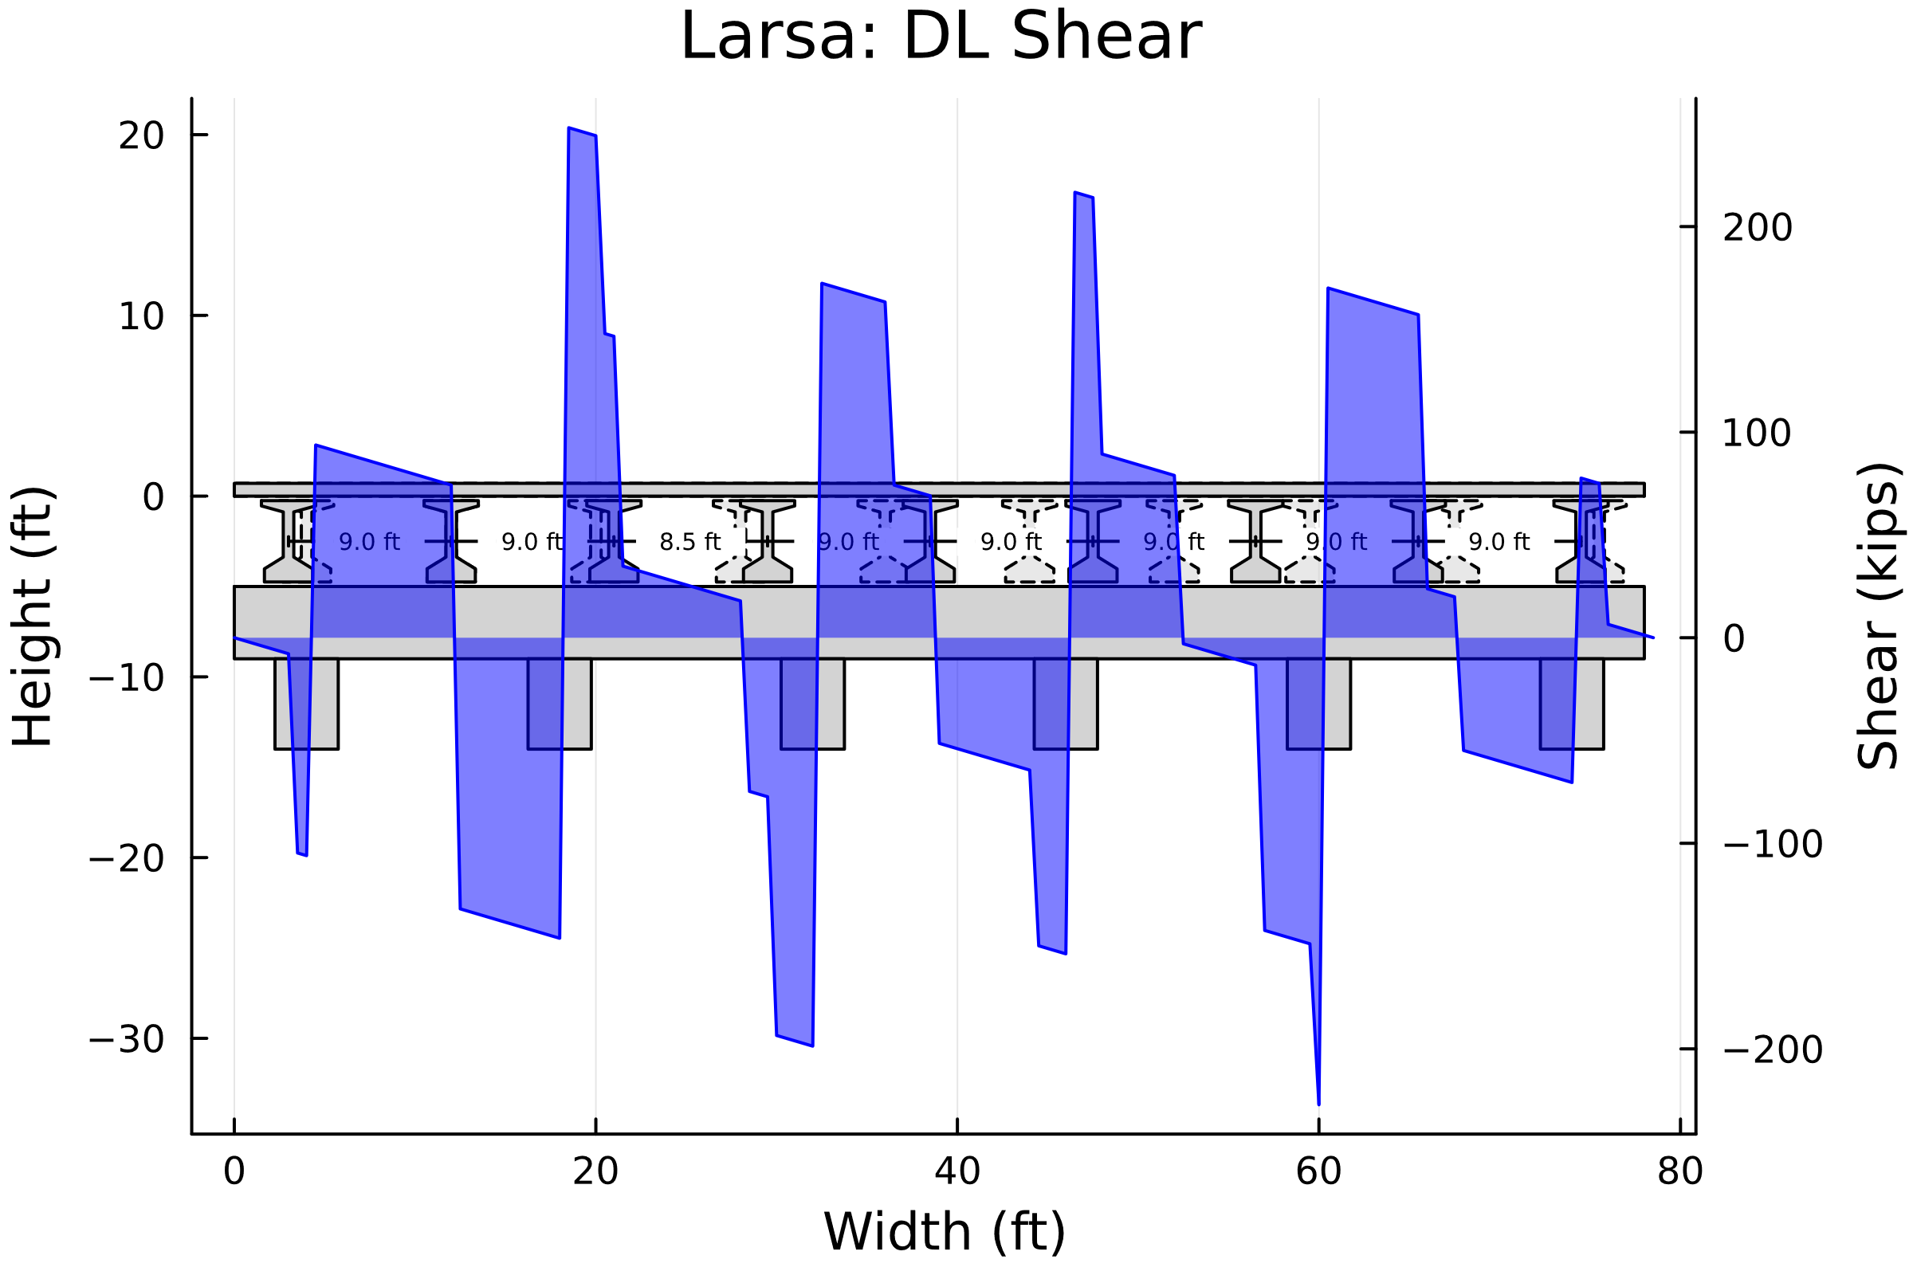

1. LARSA: DL Shear Diagram

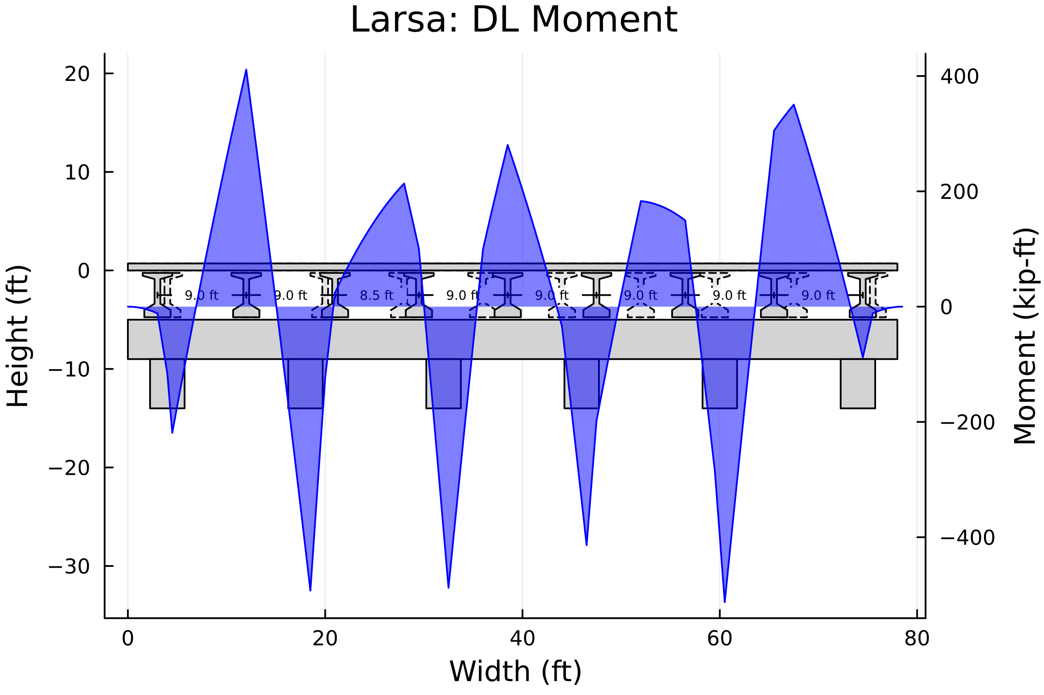

1. LARSA: DL Moment Diagram

### Envelopes of Maximum Values (SRV)

The working stress results were plotted on top of the bent to get a better visual understanding of the results. The results can be seen in the figures below. These stresses follow the same expected behavoir as the DL stresses. Further comparison with Cap18 is needed.

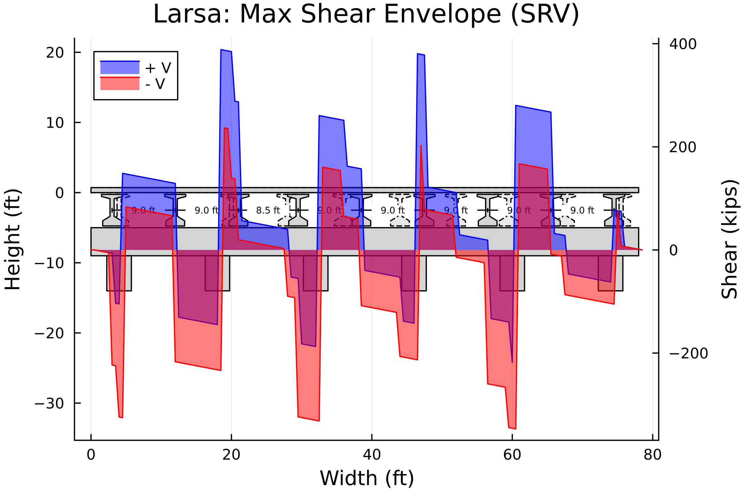

1. LARSA: Service Shear Envelope Diagram

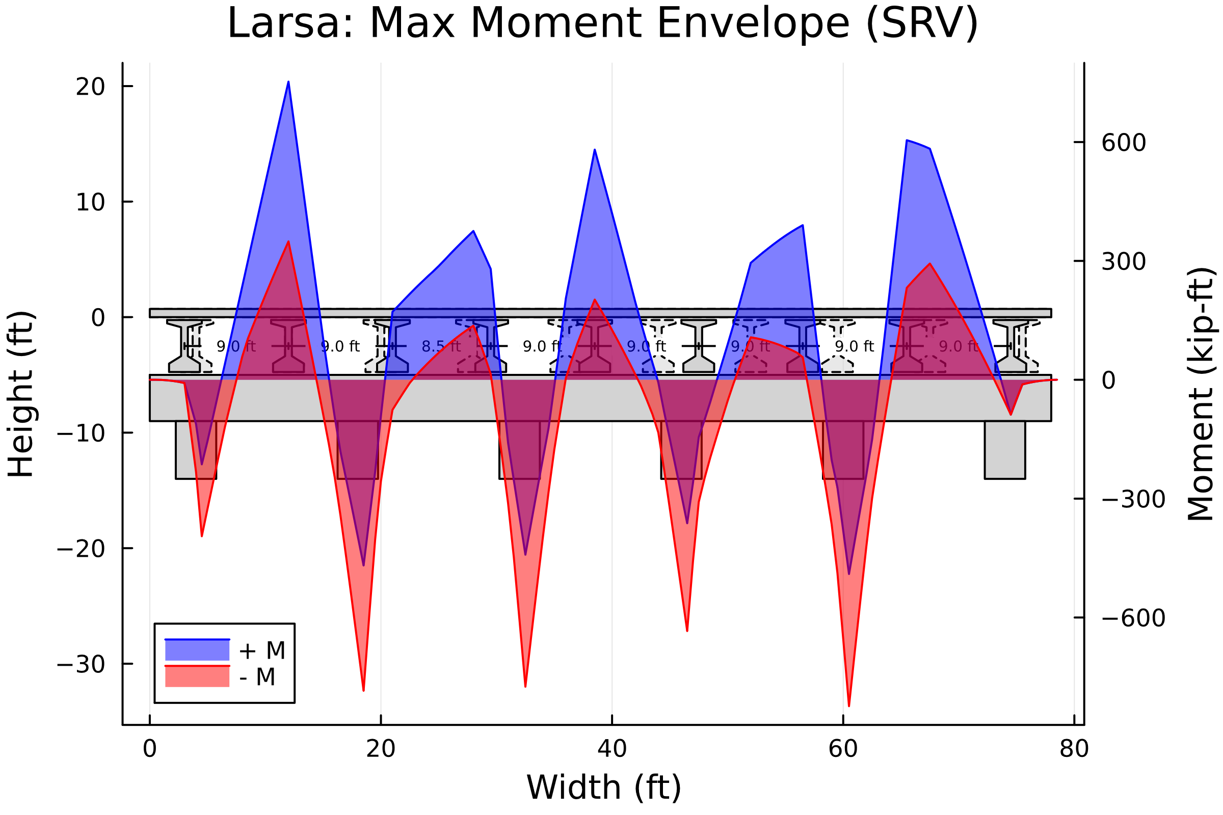

1. LARSA: Service Moment Envelope Diagram

### Maximum Support Reactions (SRV)

The maximum and minimum support reactions for the working stress case are listed in the table below.

1. LARSA: Service Reactions

| Station | Distance | Max Reactions | Min Reactions |
| --- | --- | --- | --- |
| 9 | 4.5 ft | 465.86 kip | 289.142 kip |
| 37 | 18.5 ft | 616.513 kip | 384.262 kip |
| 65 | 32.5 ft | 585.038 kip | 350.561 kip |
| 93 | 46.5 ft | 586.099 kip | 347.547 kip |
| 121 | 60.5 ft | 617.082 kip | 387.892 kip |
| 149 | 74.5 ft | 437.109 kip | 269.025 kip |

## STR

### Envelopes of Maximum Values (STR)

The load factor results were plotted on top of the bent to get a better visual understanding of the results. The results can be seen in the figures below. These stresses follow the same expected behavoir as the DL stresses. Further comparison with Cap18 is needed.

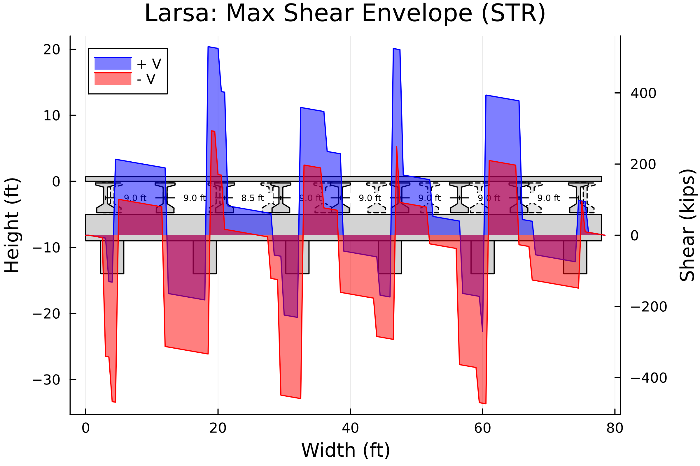

1. LARSA: Strength Shear Envelope Diagram

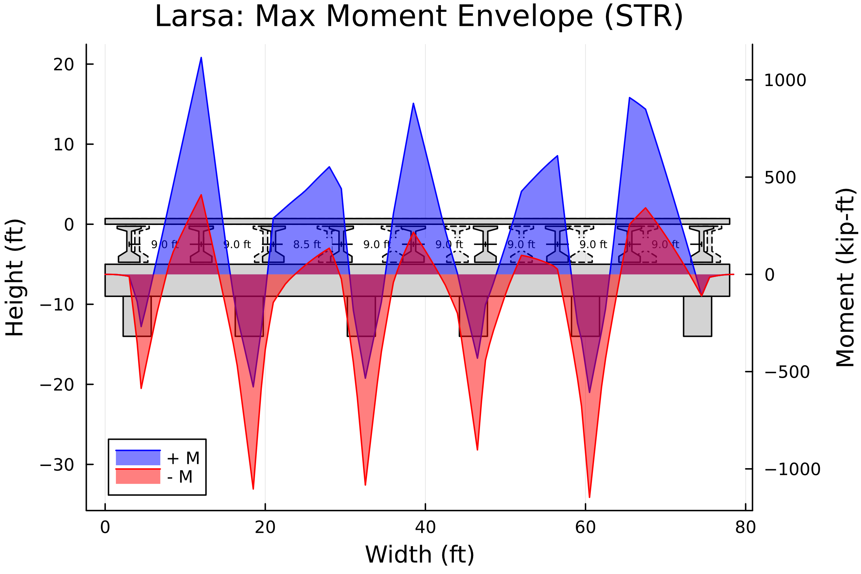

1. LARSA: Strength Moment Envelope Diagram

### Maximum Support Reactions (STR)

The maximum and minimum support reactions for the load factor case are listed in the table below.

1. LARSA: Strength Reactions

| Station | Distance | Max Reactions | Min Reactions |
| --- | --- | --- | --- |
| 9 | 4.5 ft | 669.094 kip | 359.836 kip |
| 37 | 18.5 ft | 848.741 kip | 478.514 kip |
| 65 | 32.5 ft | 809.339 kip | 431.215 kip |
| 93 | 46.5 ft | 807.774 kip | 426.186 kip |
| 121 | 60.5 ft | 852.34 kip | 483.67 kip |
| 149 | 74.5 ft | 628.815 kip | 334.667 kip |

# Comparison

Below is a comparison of the Cap18 and Larsa results. Stresses were found to be fairly similar between the different programs. The main differences are in the shear stresses. Cap18 seems to have a more gradual change in shear compared to Larsa. This is most likely due to the way Cap18 defines the point loads in the program. This gradual vs more sharp change in shear does not seem to affect the moment diagram in a significant way. Moment diagram stresses do show some differences and will be discussed in more detail below.

**Important Plot Information**  
The comparison plots for the shear and moment diagrams are shown below for all the different load cases. The Cap18 results are shown in a blue line and the larsa results are shown in a red line. The red line will only really be visible when the larsa results are greater in magnitude than the cap18 results. The thickness of the red or blue line shows how much greater in magnitdue the respective result was. The absolute difference between larsa and cap18 is show in yellow. Any positive yellow results indicate that larsa was greater in magnitude. Data labels are also visible for the moment diagrams at the local extrema. Text in blue indicates that Cap18 was greater in magnitude, while red text indicates larsa results were greater in magnitude.

## SRV

### Dead Load Results (SRV)

The figures below compare the DL results between the two programs. The areas in red highlight where larsa results were greater in magnitude than the cap18 results. There are some visible red areas in the shear diagram. However, these can be explained by the difference in point load modeling between the two programs. The maximum values are shown to be very similar. In areas of maximum moment and shears, the results are within 3%.

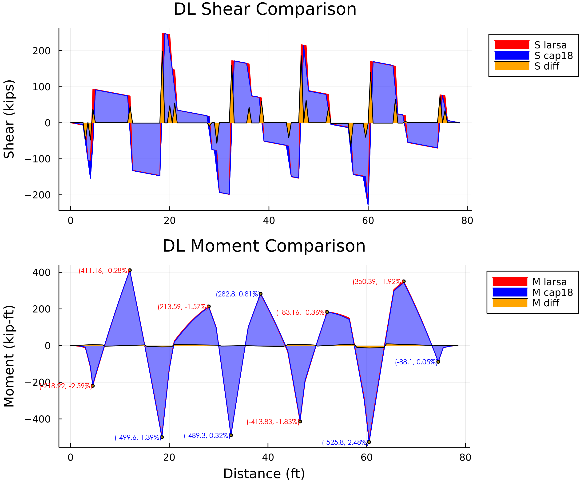

1. Comparison: DL Shear and Moment Diagrams

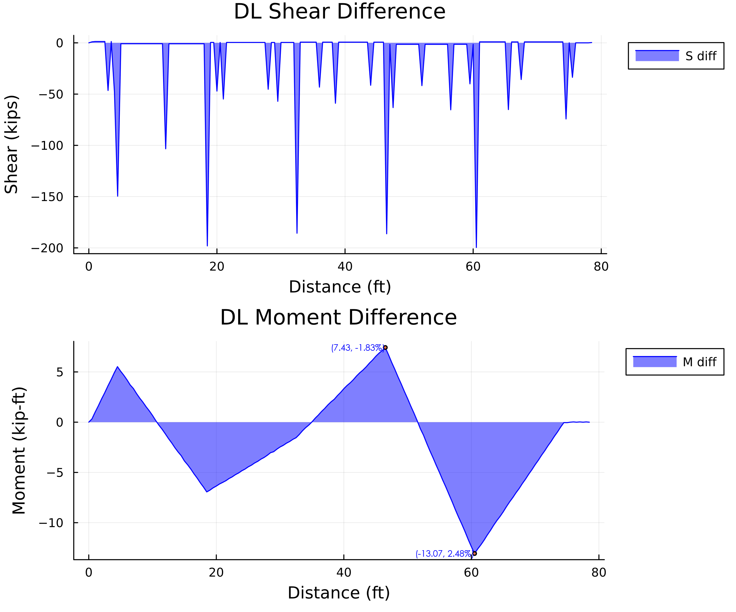

1. Comparison: DL Shear and Moment Difference

### Envelopes of Maximum Values (SRV)

#### Maximum Envelope Comparison

The figures below compare the working stress results for the maximum stress envelope between the two programs. The areas in red highlight where larsa results were greater in magnitude than the cap18 results. There are some visible red areas in the shear diagram. However, these can be explained by the difference in point load modeling between the two programs. The maximum values are shown to be very similar. In areas of maximum moment and shears, the results are within 3%.

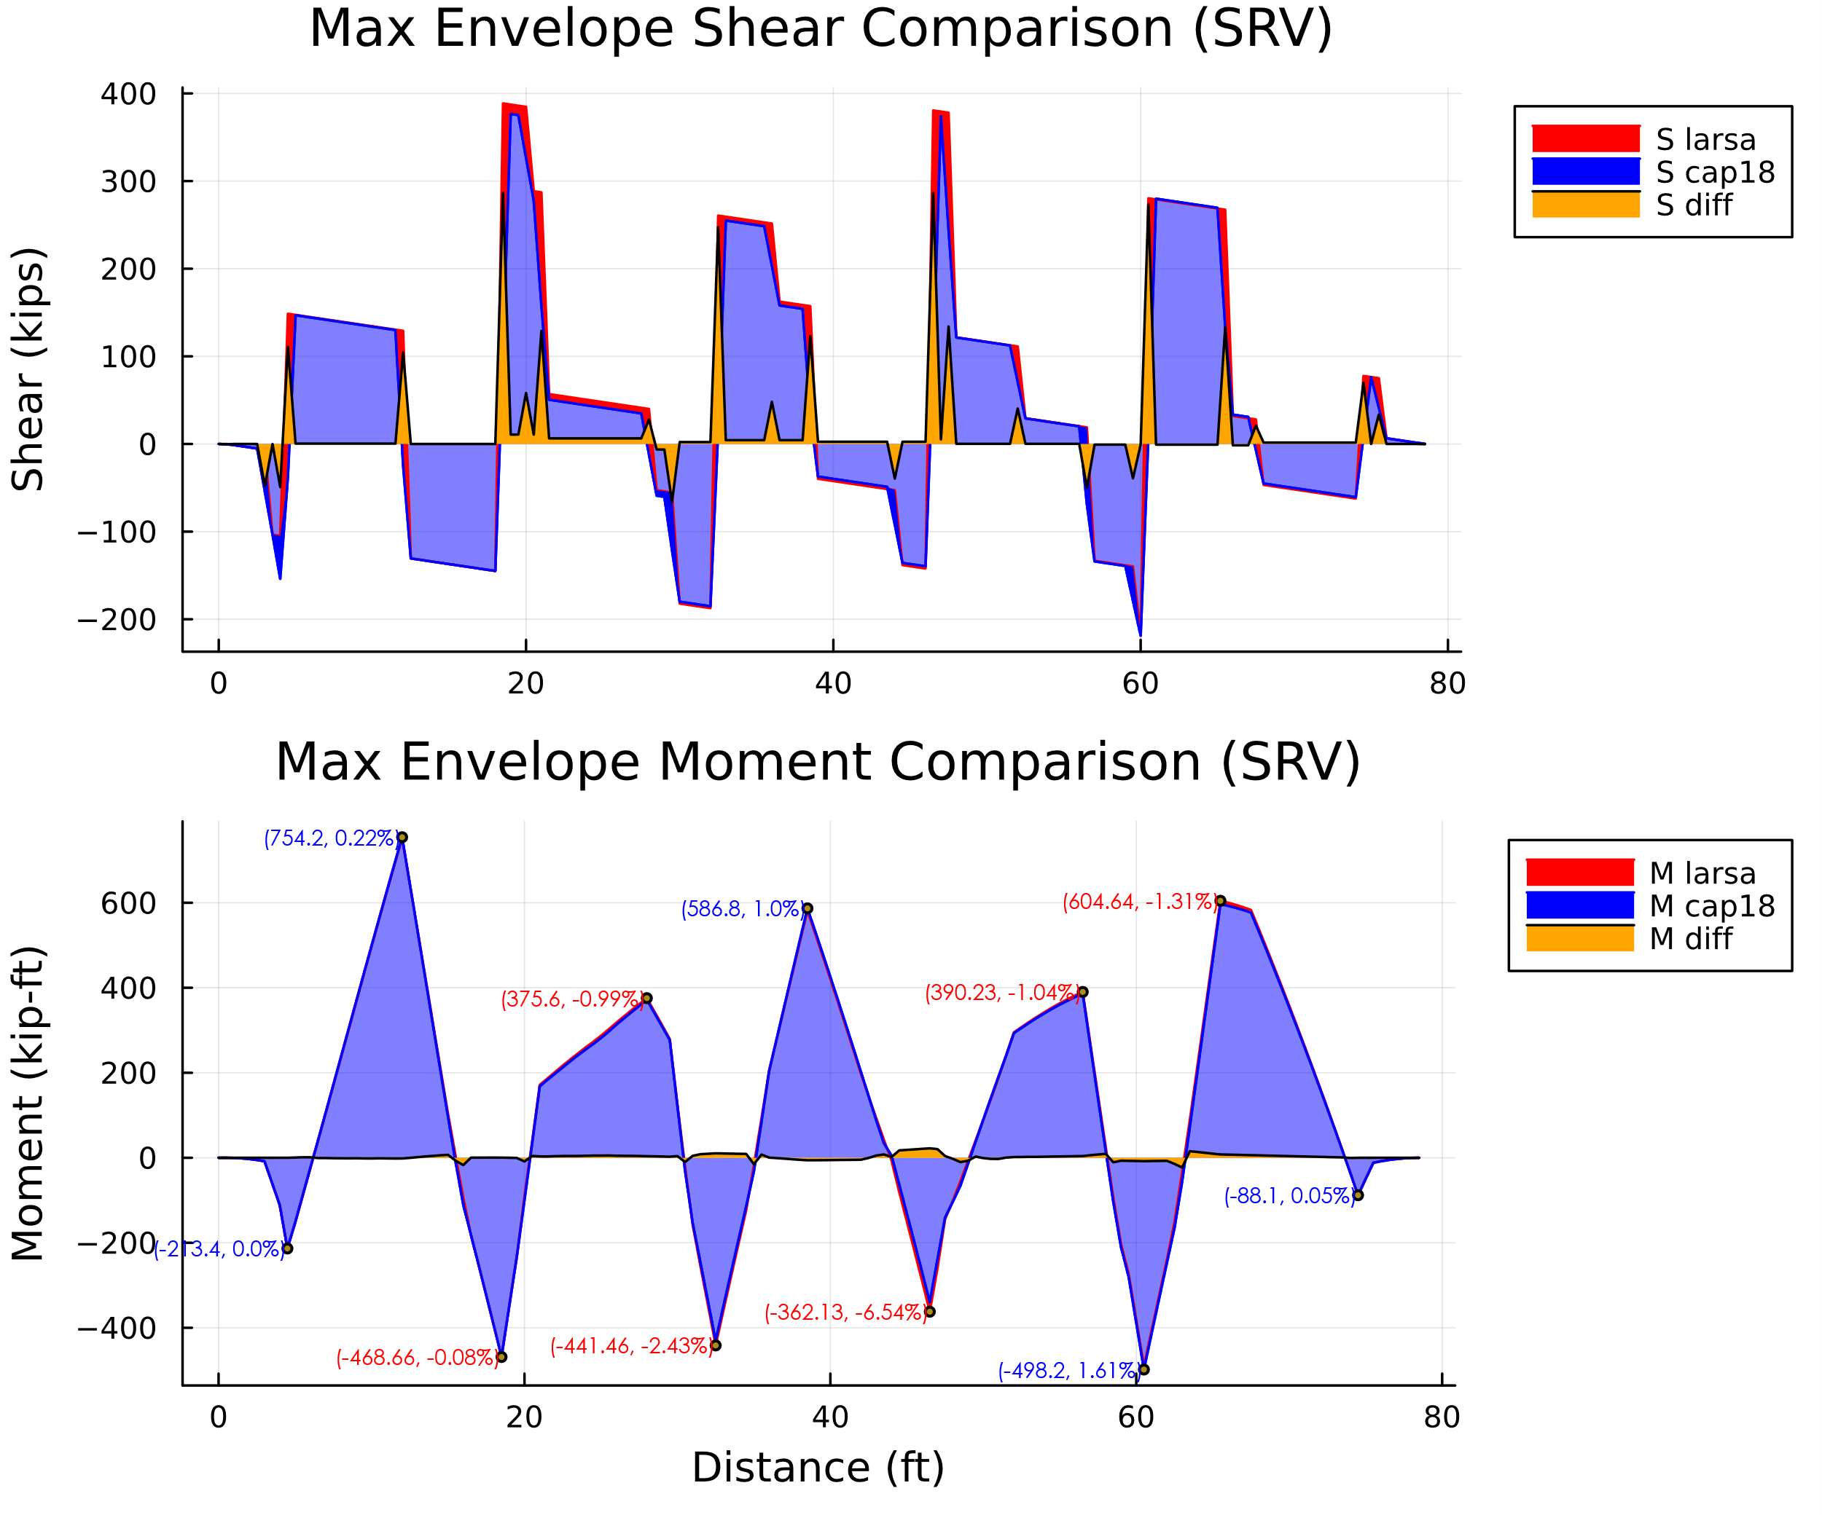

1. Comparison: Service Shear and Moment Max Envelope Diagrams

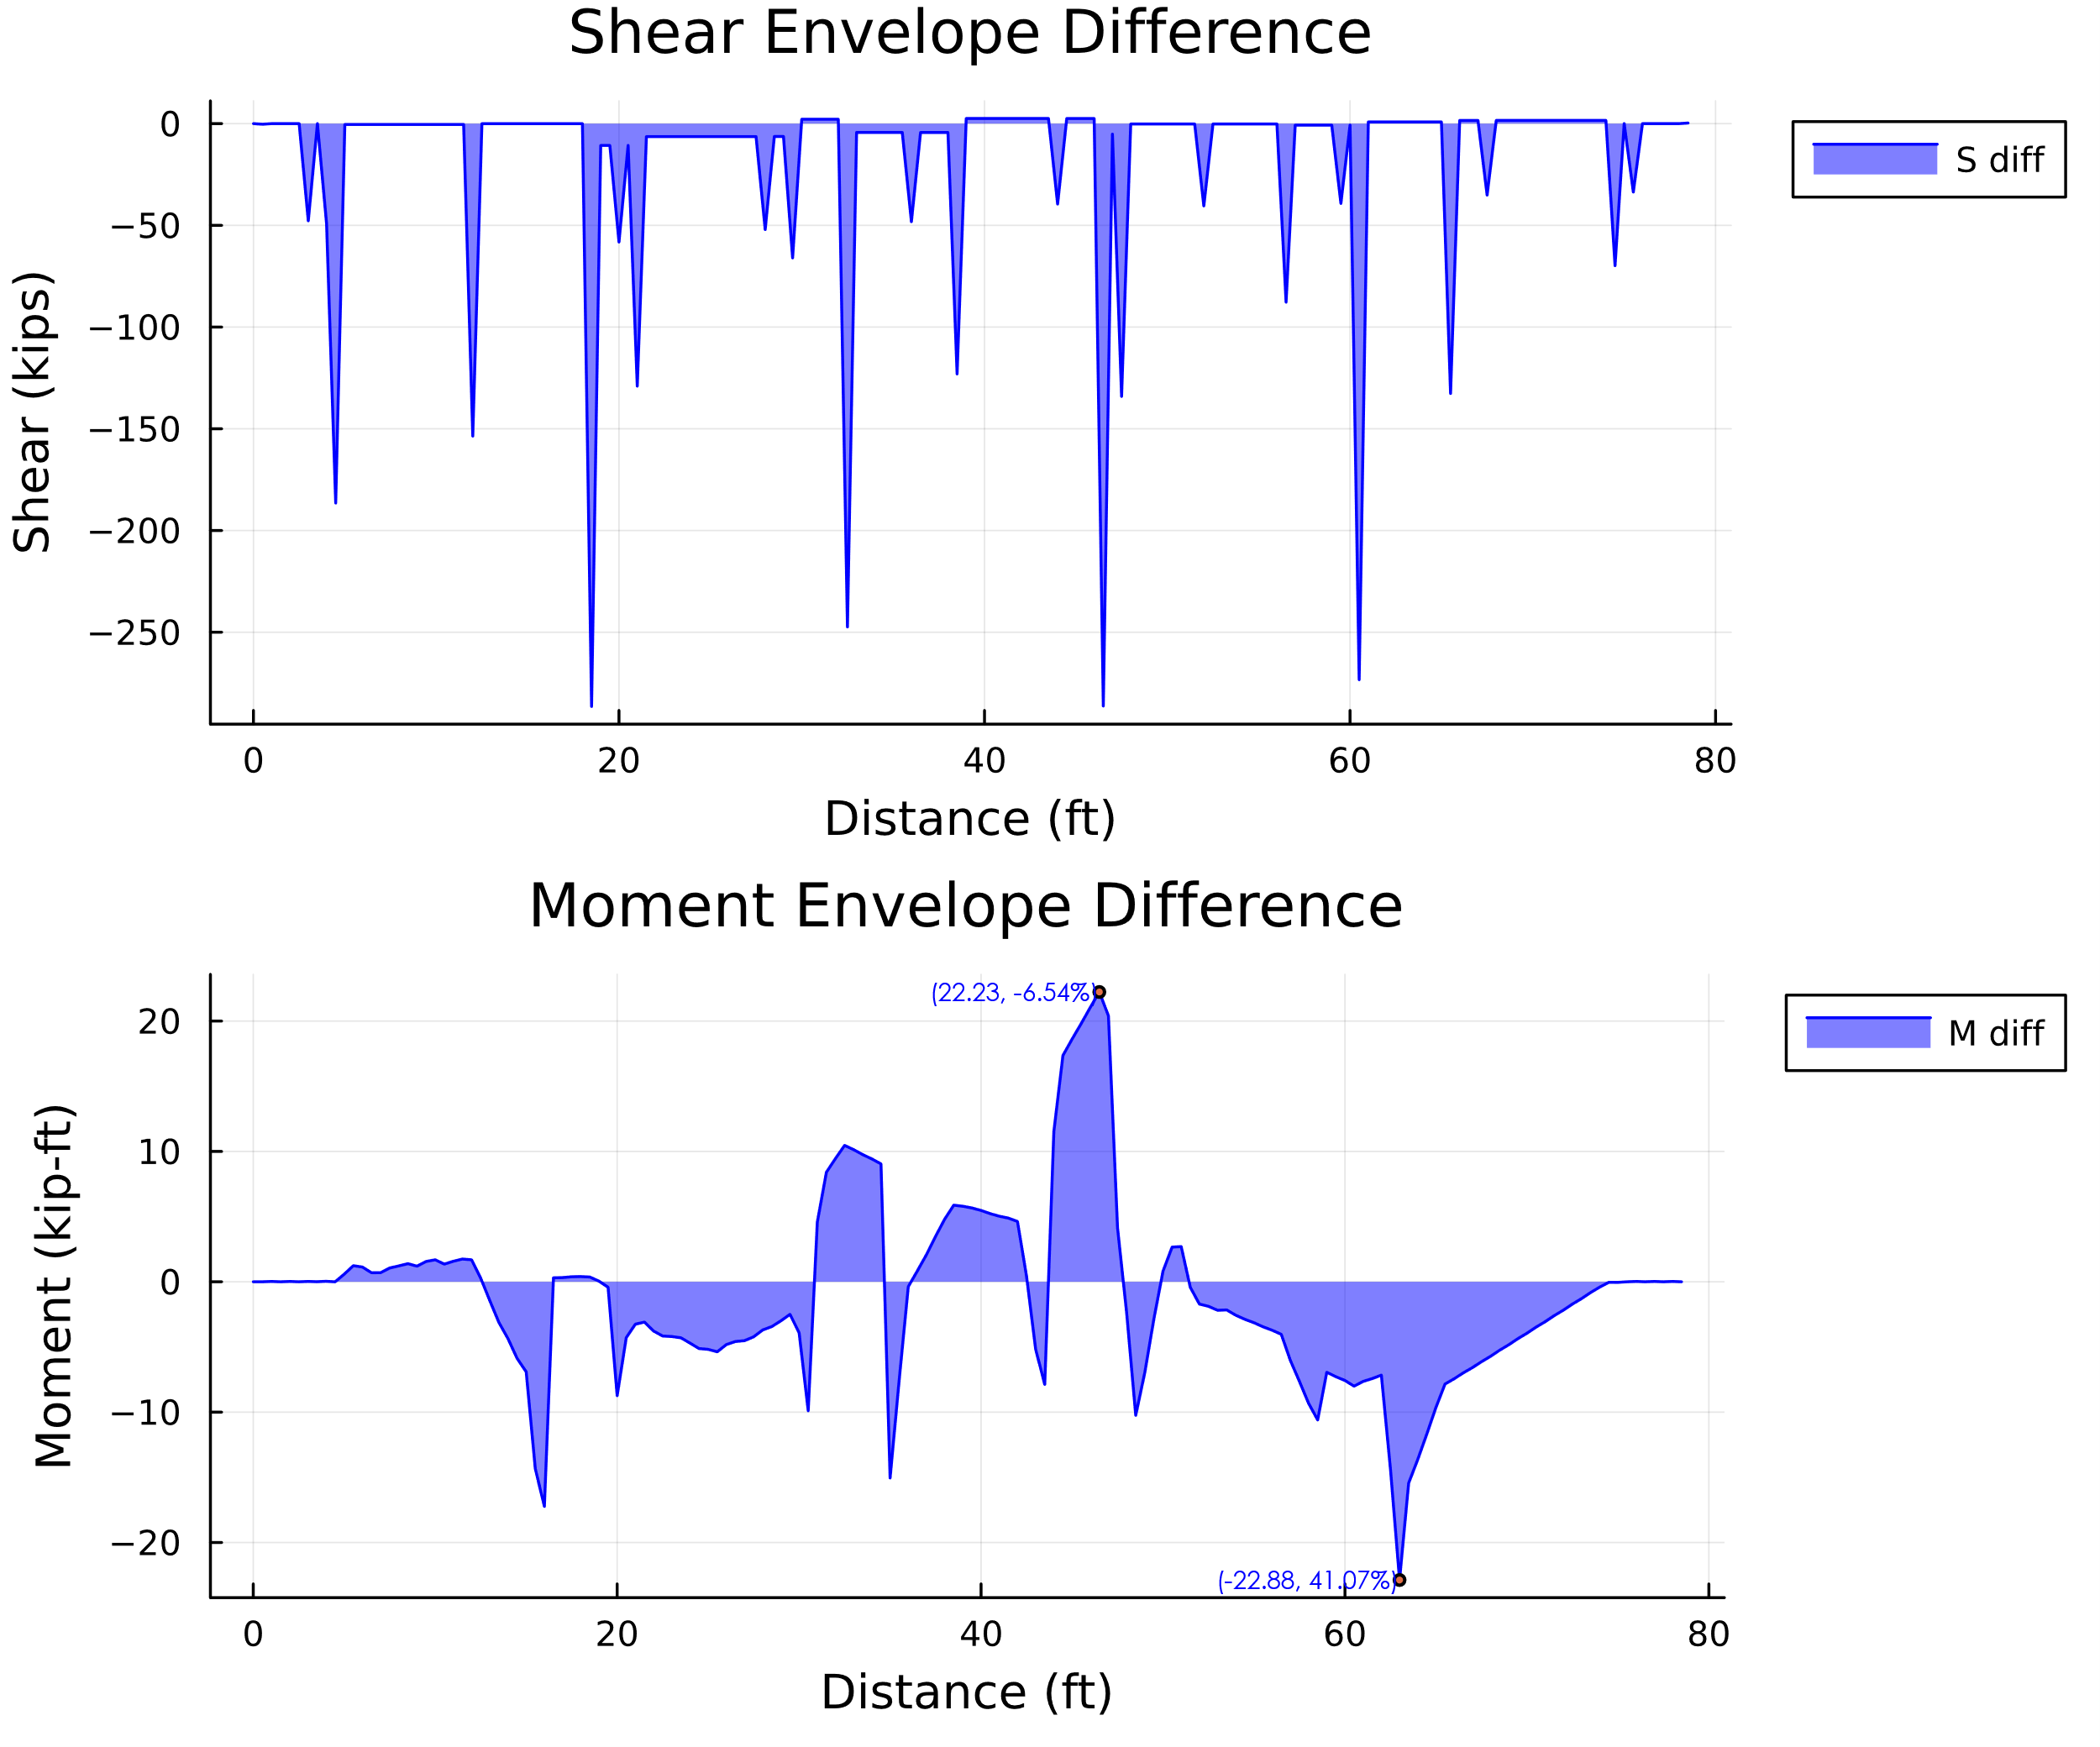

1. Comparison: Service Shear and Moment Max Envelope Difference

#### Minimum Envelope Comparison

The figures below compare the working stress results for the minimum stress envelope between the two programs. The areas in red (not the light red areas) highlight where larsa results were greater in magnitude than the cap18 results. There are some visible red areas in the shear diagram. However, these can be explained by the difference in point load modeling between the two programs. . In areas of maximum moment and shears, the results are within 4%.

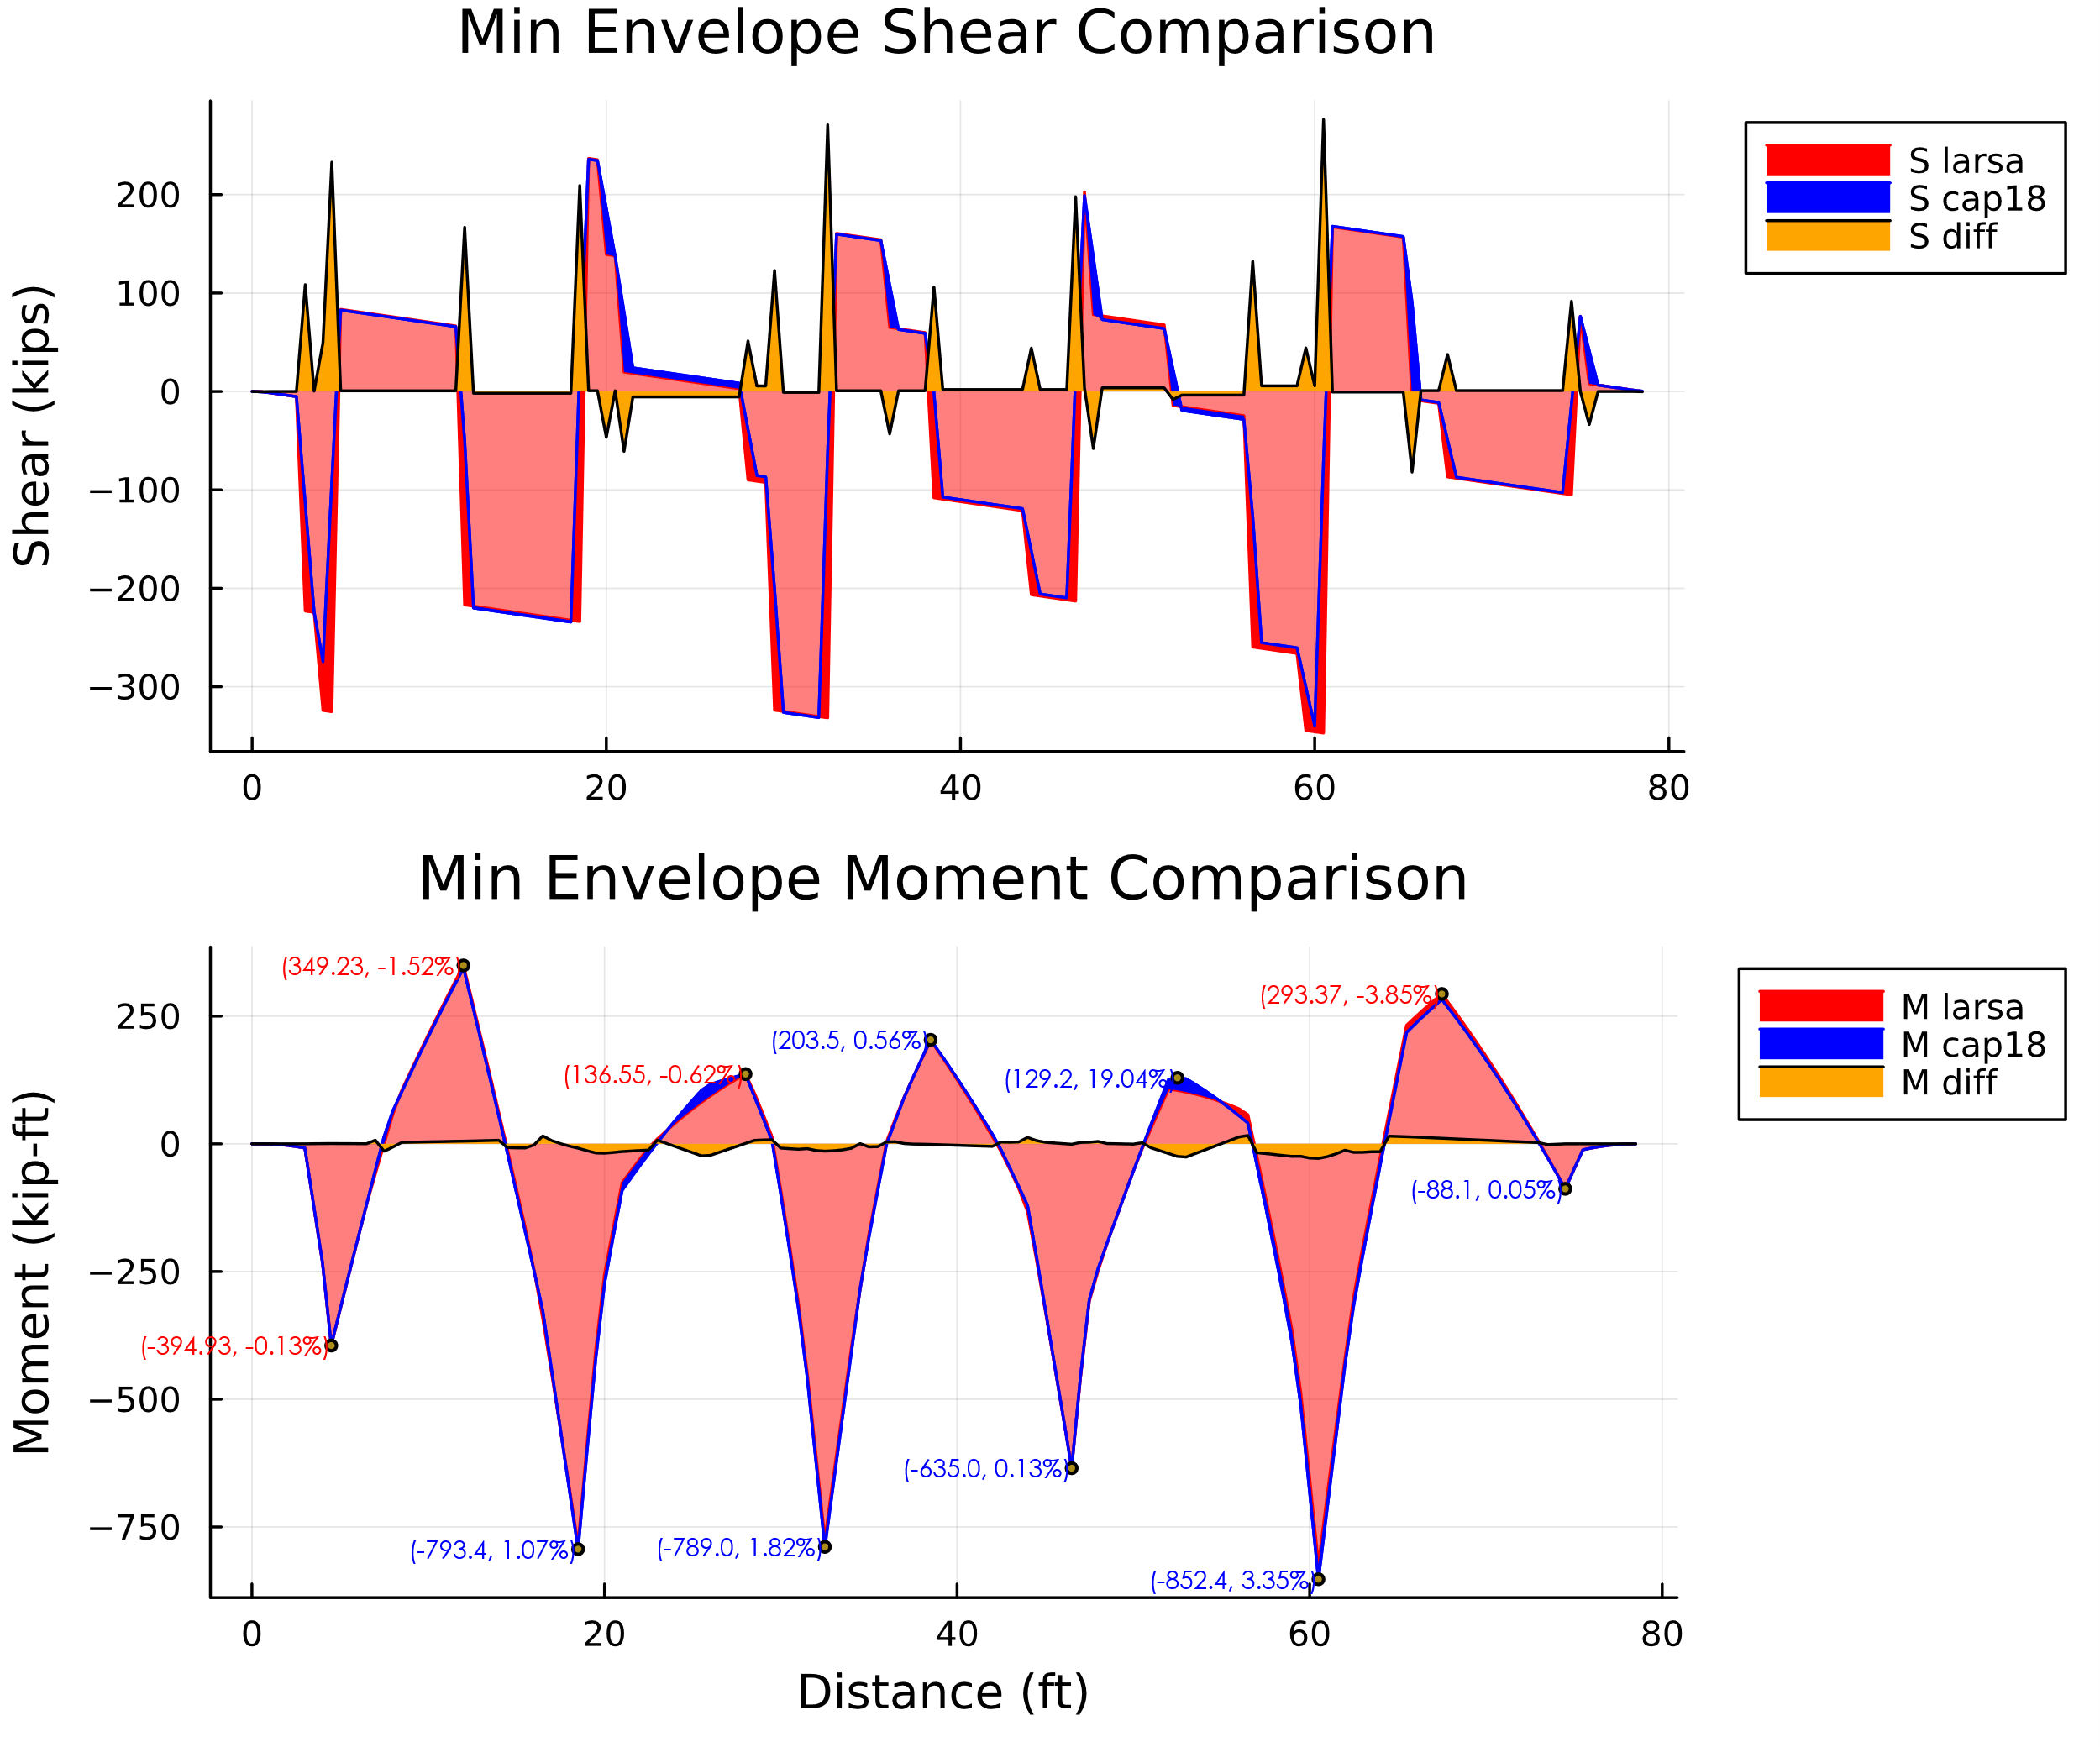

1. Comparison: Service Shear and Moment Min Envelope Diagrams

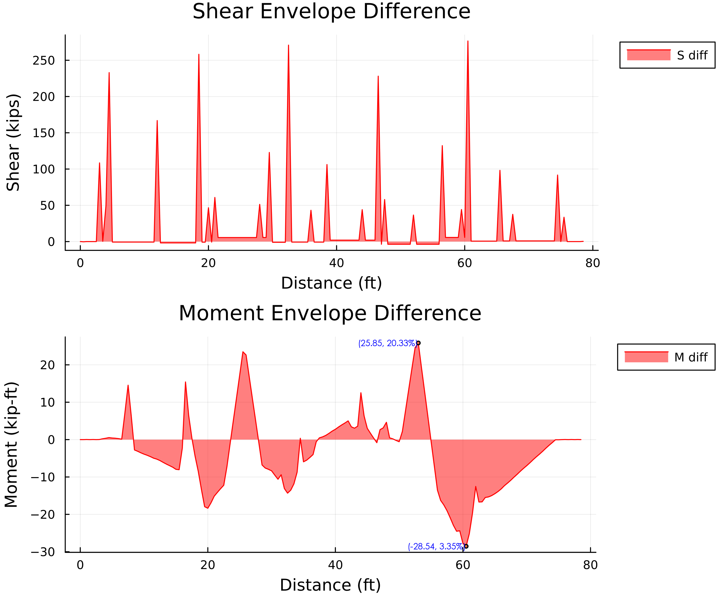

1. Comparison: Service Shear and Moment Min Envelope Difference

### Live Load Comparison (SRV)

The figures below compare the working stress results for the maximum stress envelope of the live load between the two programs. The areas in red highlight where larsa results were greater in magnitude than the cap18 results. There are some visible red areas in the shear diagram. However, some of the differences can be explained by the difference in point load modeling between the two programs. The other shear areas where larsa results look to be higher in magnitude could potentially be explained by the difference in how the programs run the live load. The Larsa modeling of the live load is a little limited and conservative methods were used.

The maximum moment values are shown to be very similar. In areas of maximum moment, the results are within 3%.

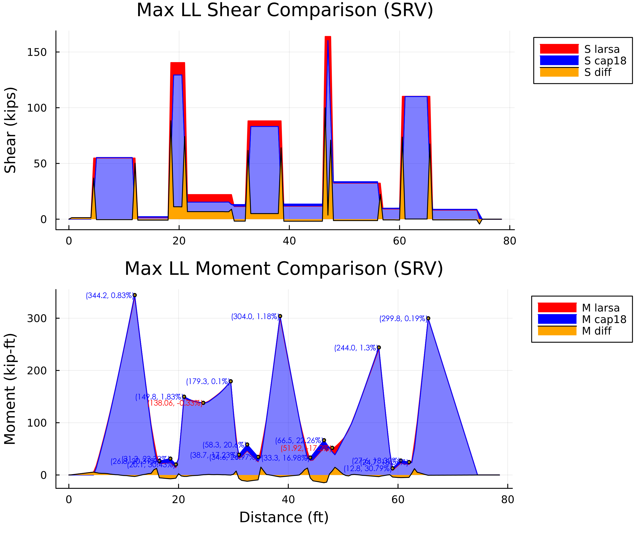

1. Comparison: Service Shear and Moment Max LL Envelope Diagrams

The figures below compare the working stress results for the minimum stress envelope of the live load between the two programs. The areas in red (not the light red areas) highlight where larsa results were greater in magnitude than the cap18 results. There are some visible red areas in the shear diagram. However, these can be explained by the difference in point load modeling between the two programs. There are also large red spikes in the shear diagram for the larsa results. This is also a sign there are some unrealistic modeling behaviors in the larsa model.

The maximum moment values are shown to be very similar. In areas of maximum moment, the results are within 5%.

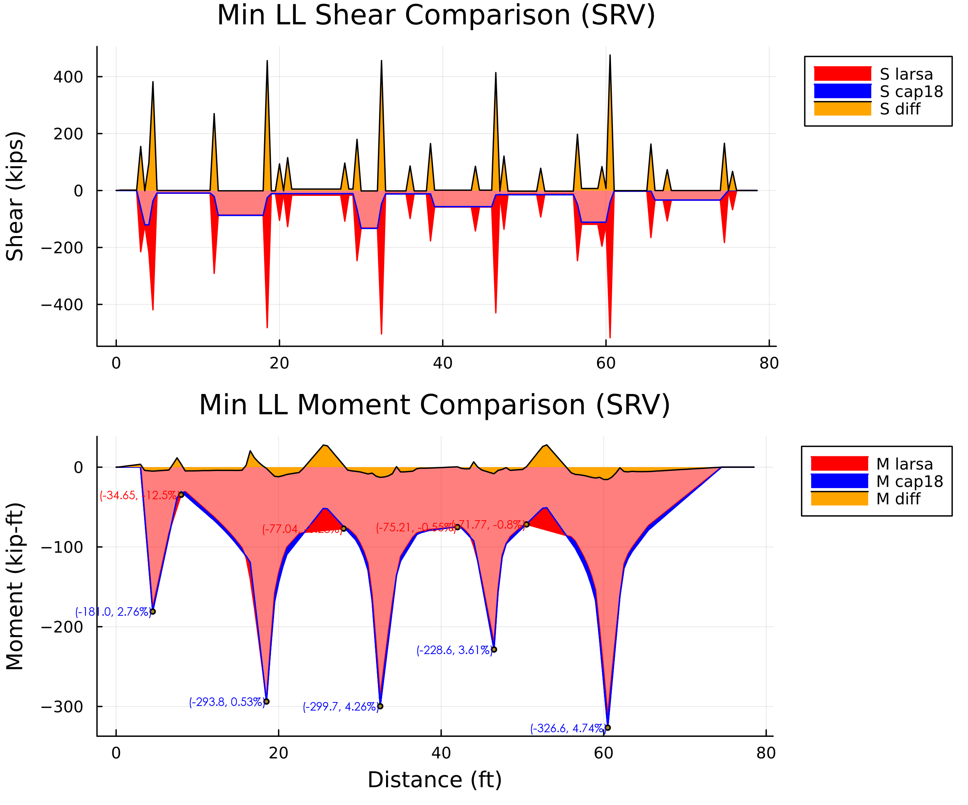

1. Comparison: Service Shear and Moment Min LL Envelope Diagrams

### Maximum Support Reactions (SRV)

The figure below compares the working stress results for the maximum and minimum reactions between the two programs. The results between programs are within 1% of eachother.

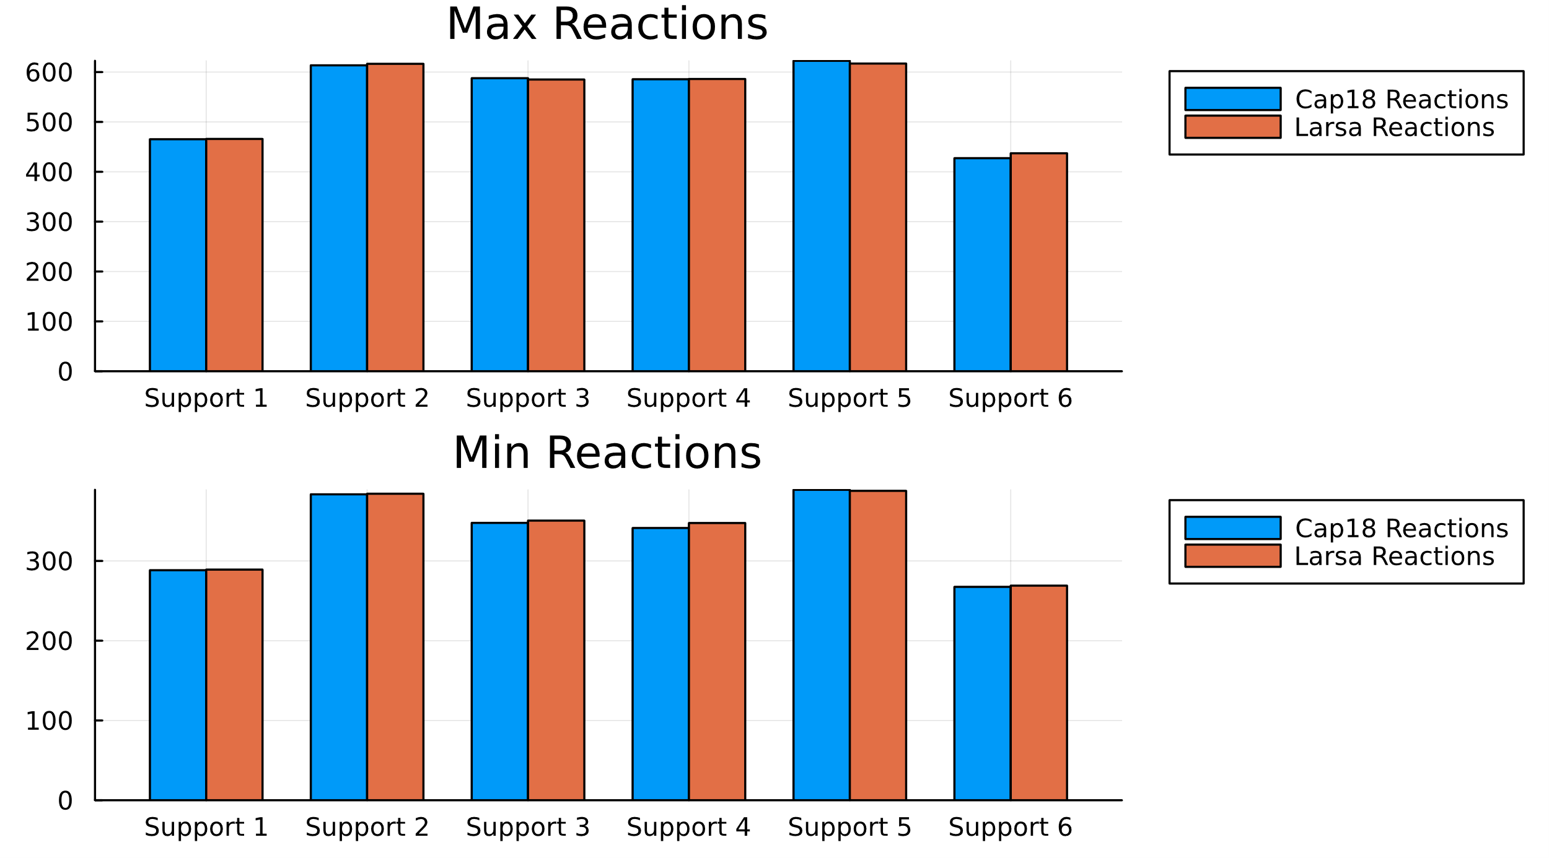

1. Comparison: Service Reactions

## STR

### Envelopes of Maximum Values (STR)

The figures below compare the load factor results for the maximum stress envelope between the two programs. The areas in red highlight where larsa results were greater in magnitude than the cap18 results. There are some visible red areas in the shear diagram. However, these can be explained by the difference in point load modeling between the two programs. The maximum values are shown to be very similar. In areas of maximum moment, the results are within 3%.

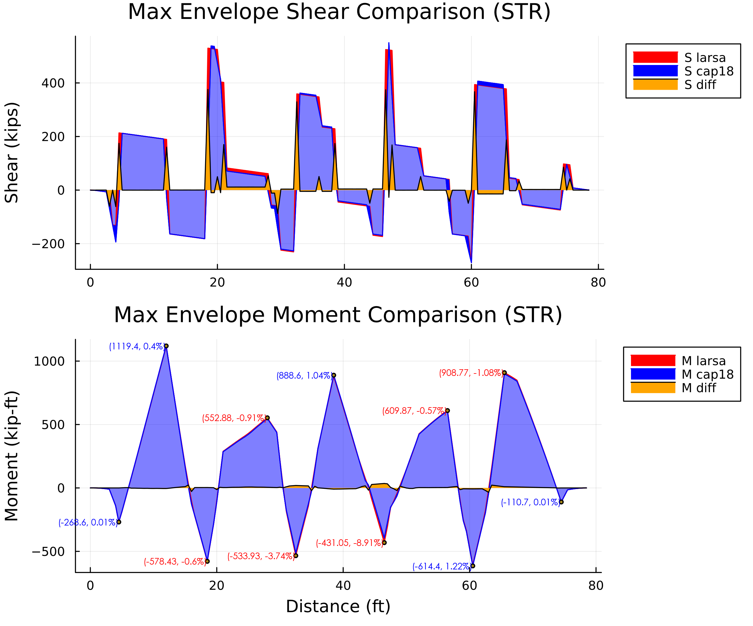

1. Comparison: Strength Shear and Moment Max Envelope Diagrams

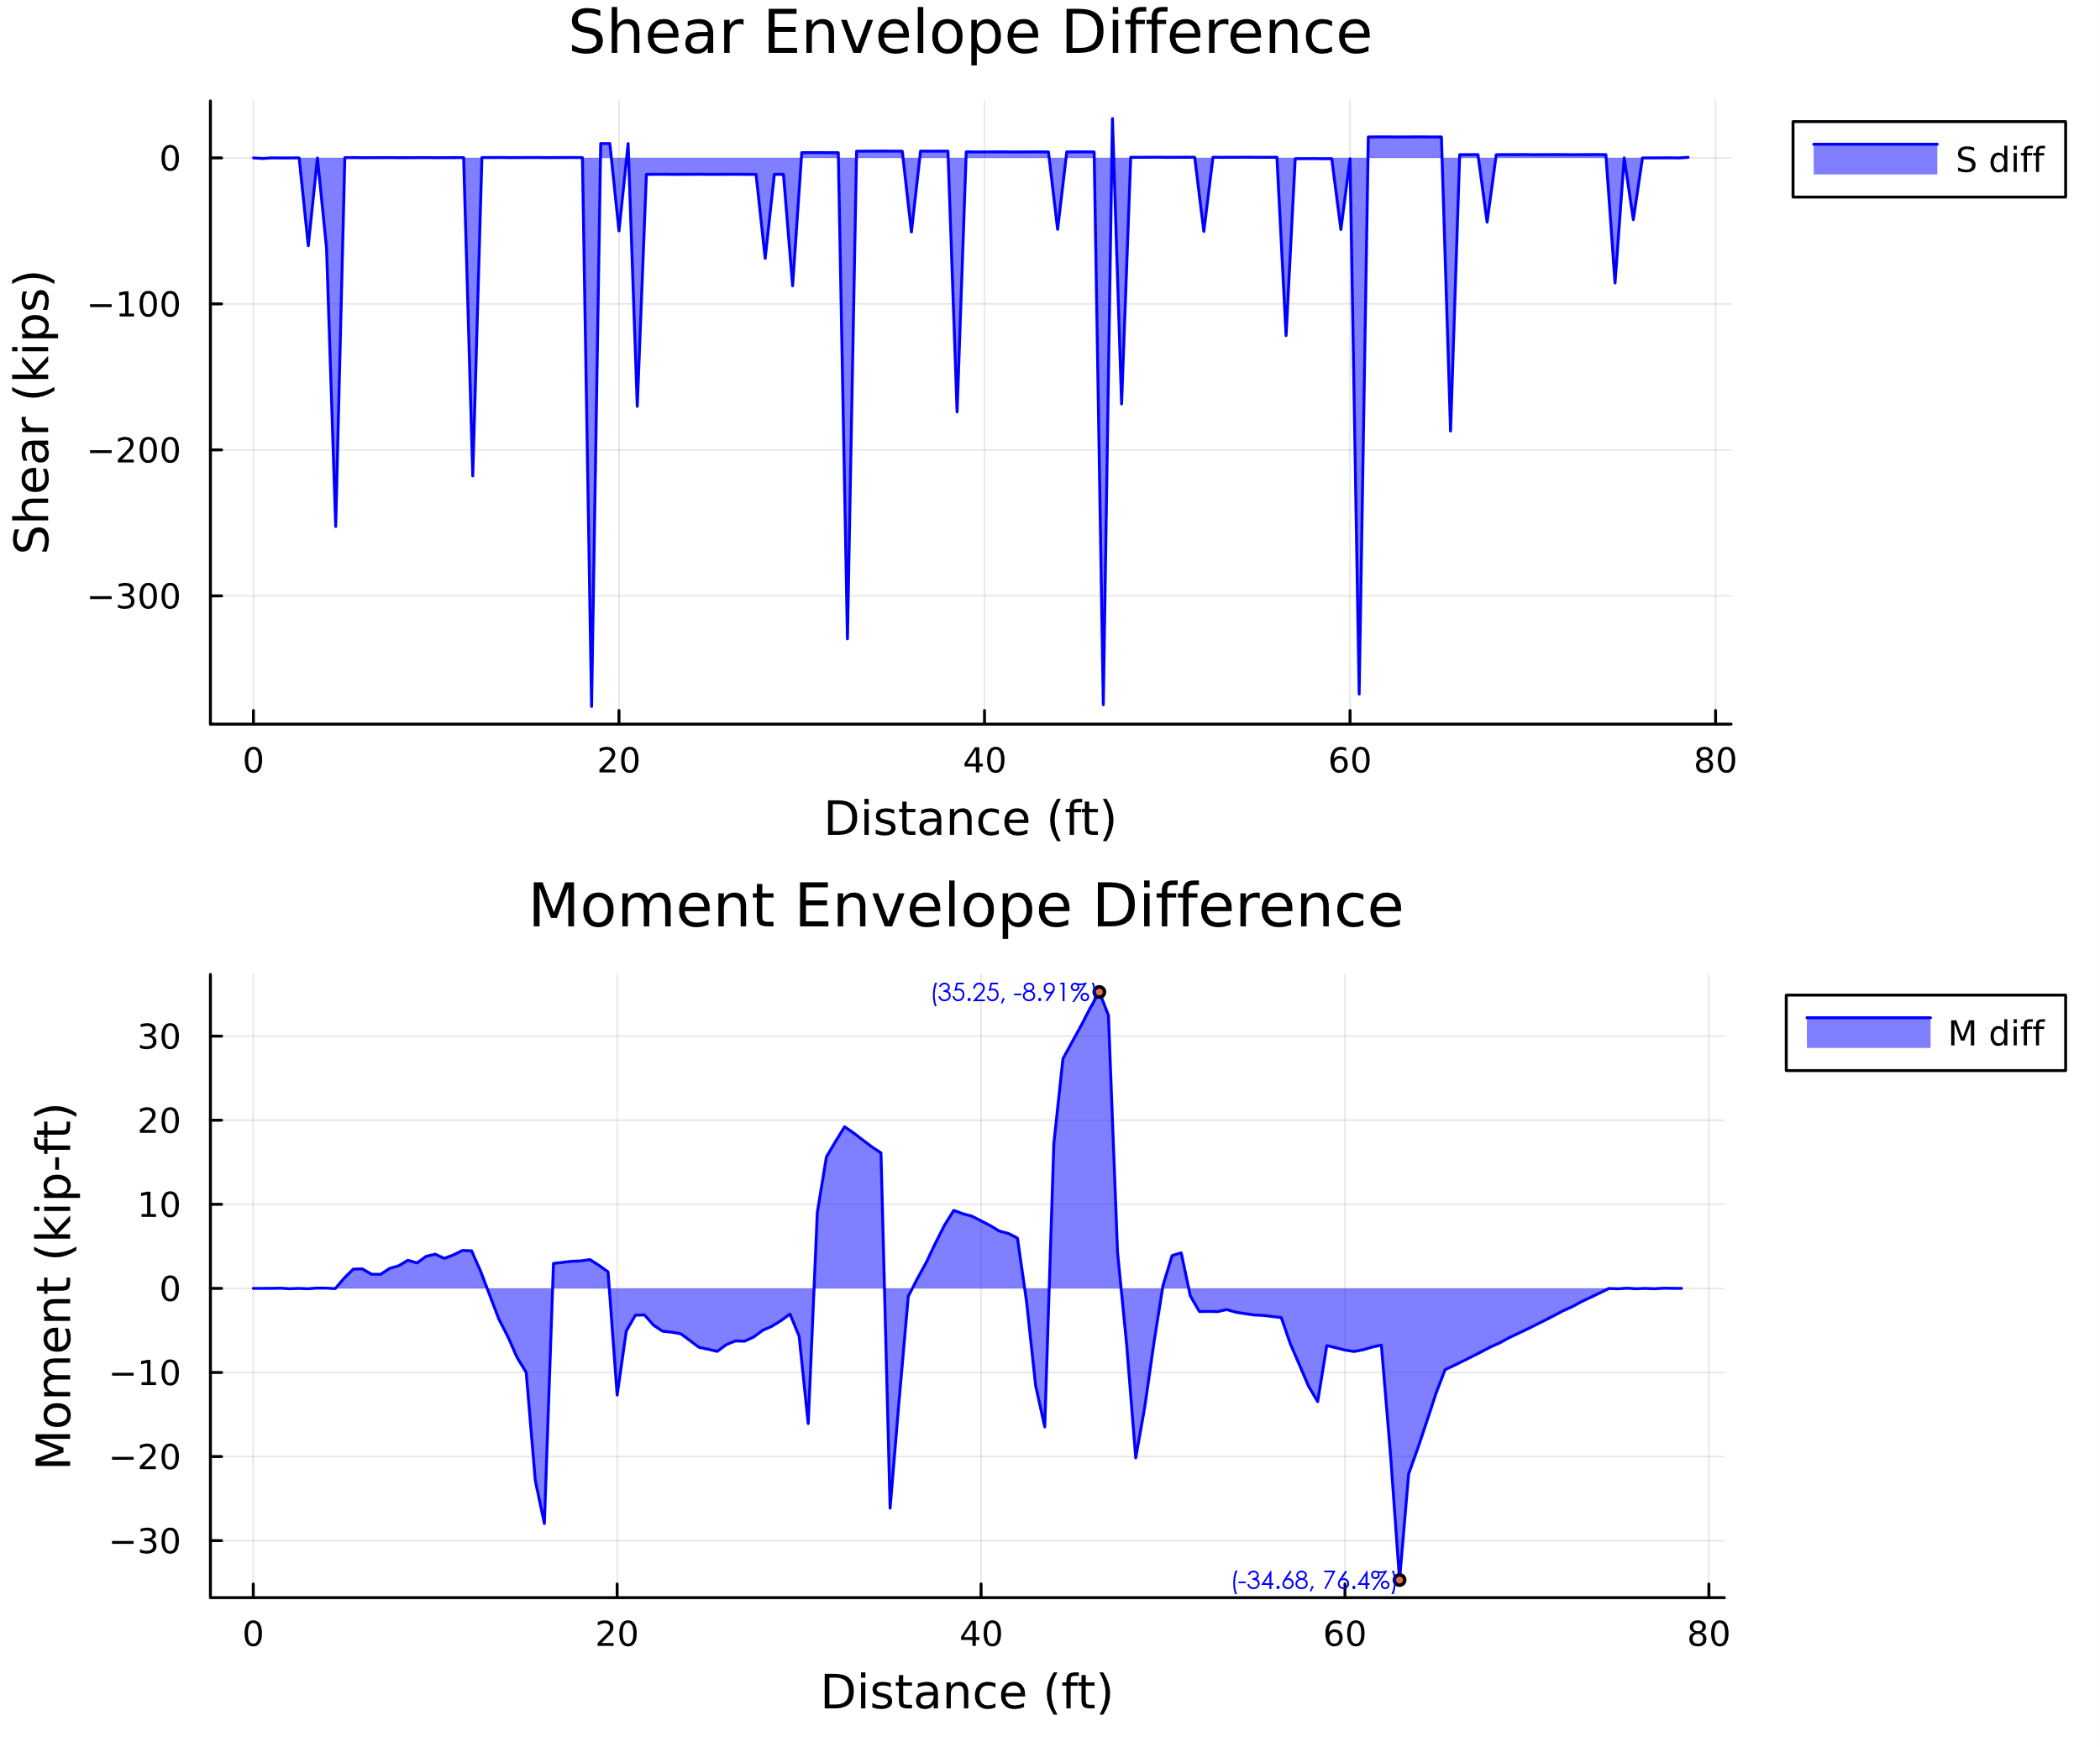

1. Comparison: Strength Shear and Moment Max Envelope Difference

The figures below compare the load factor results for the minimum stress envelope between the two programs. The areas in red (not the light red areas) highlight where larsa results were greater in magnitude than the cap18 results. There are some visible red areas in the shear diagram. However, these can be explained by the difference in point load modeling between the two programs. . In areas of maximum moment and shears, the results are within 8%. Areas where larsa results are greater than cap18 are within 5% (these areas are also positive moments when negative moment are being maximized).

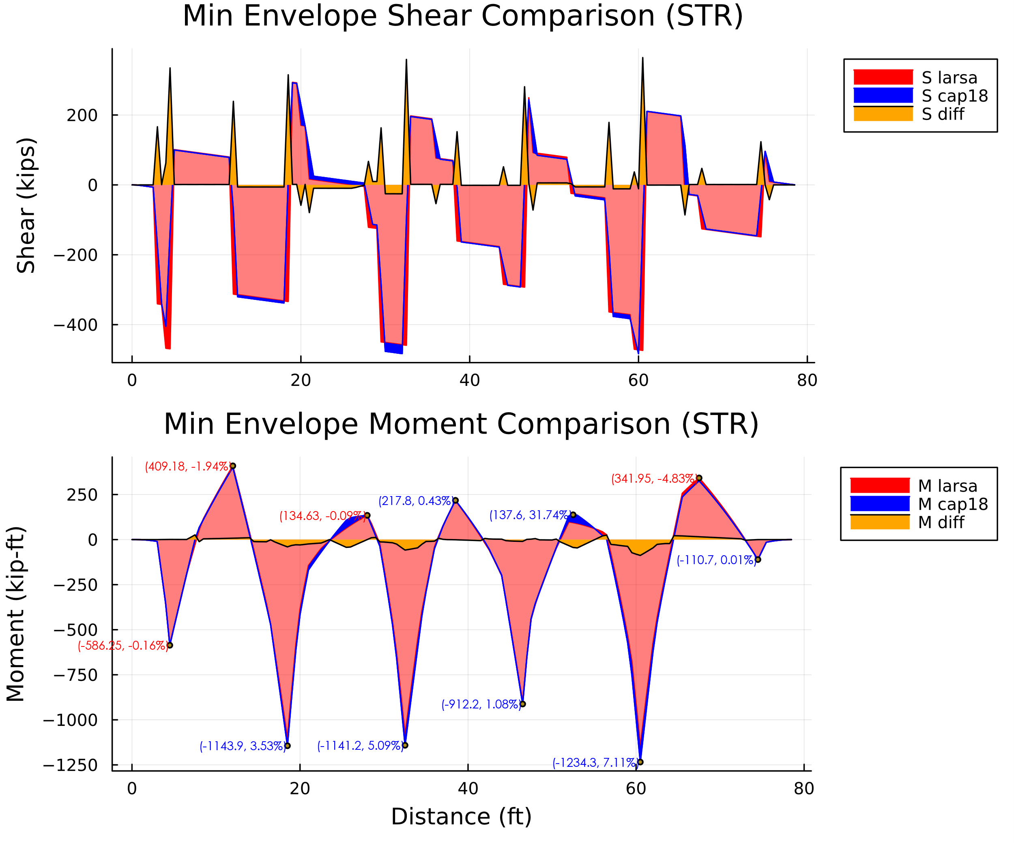

1. Comparison: Strength Shear and Moment Min LL Envelope Diagrams

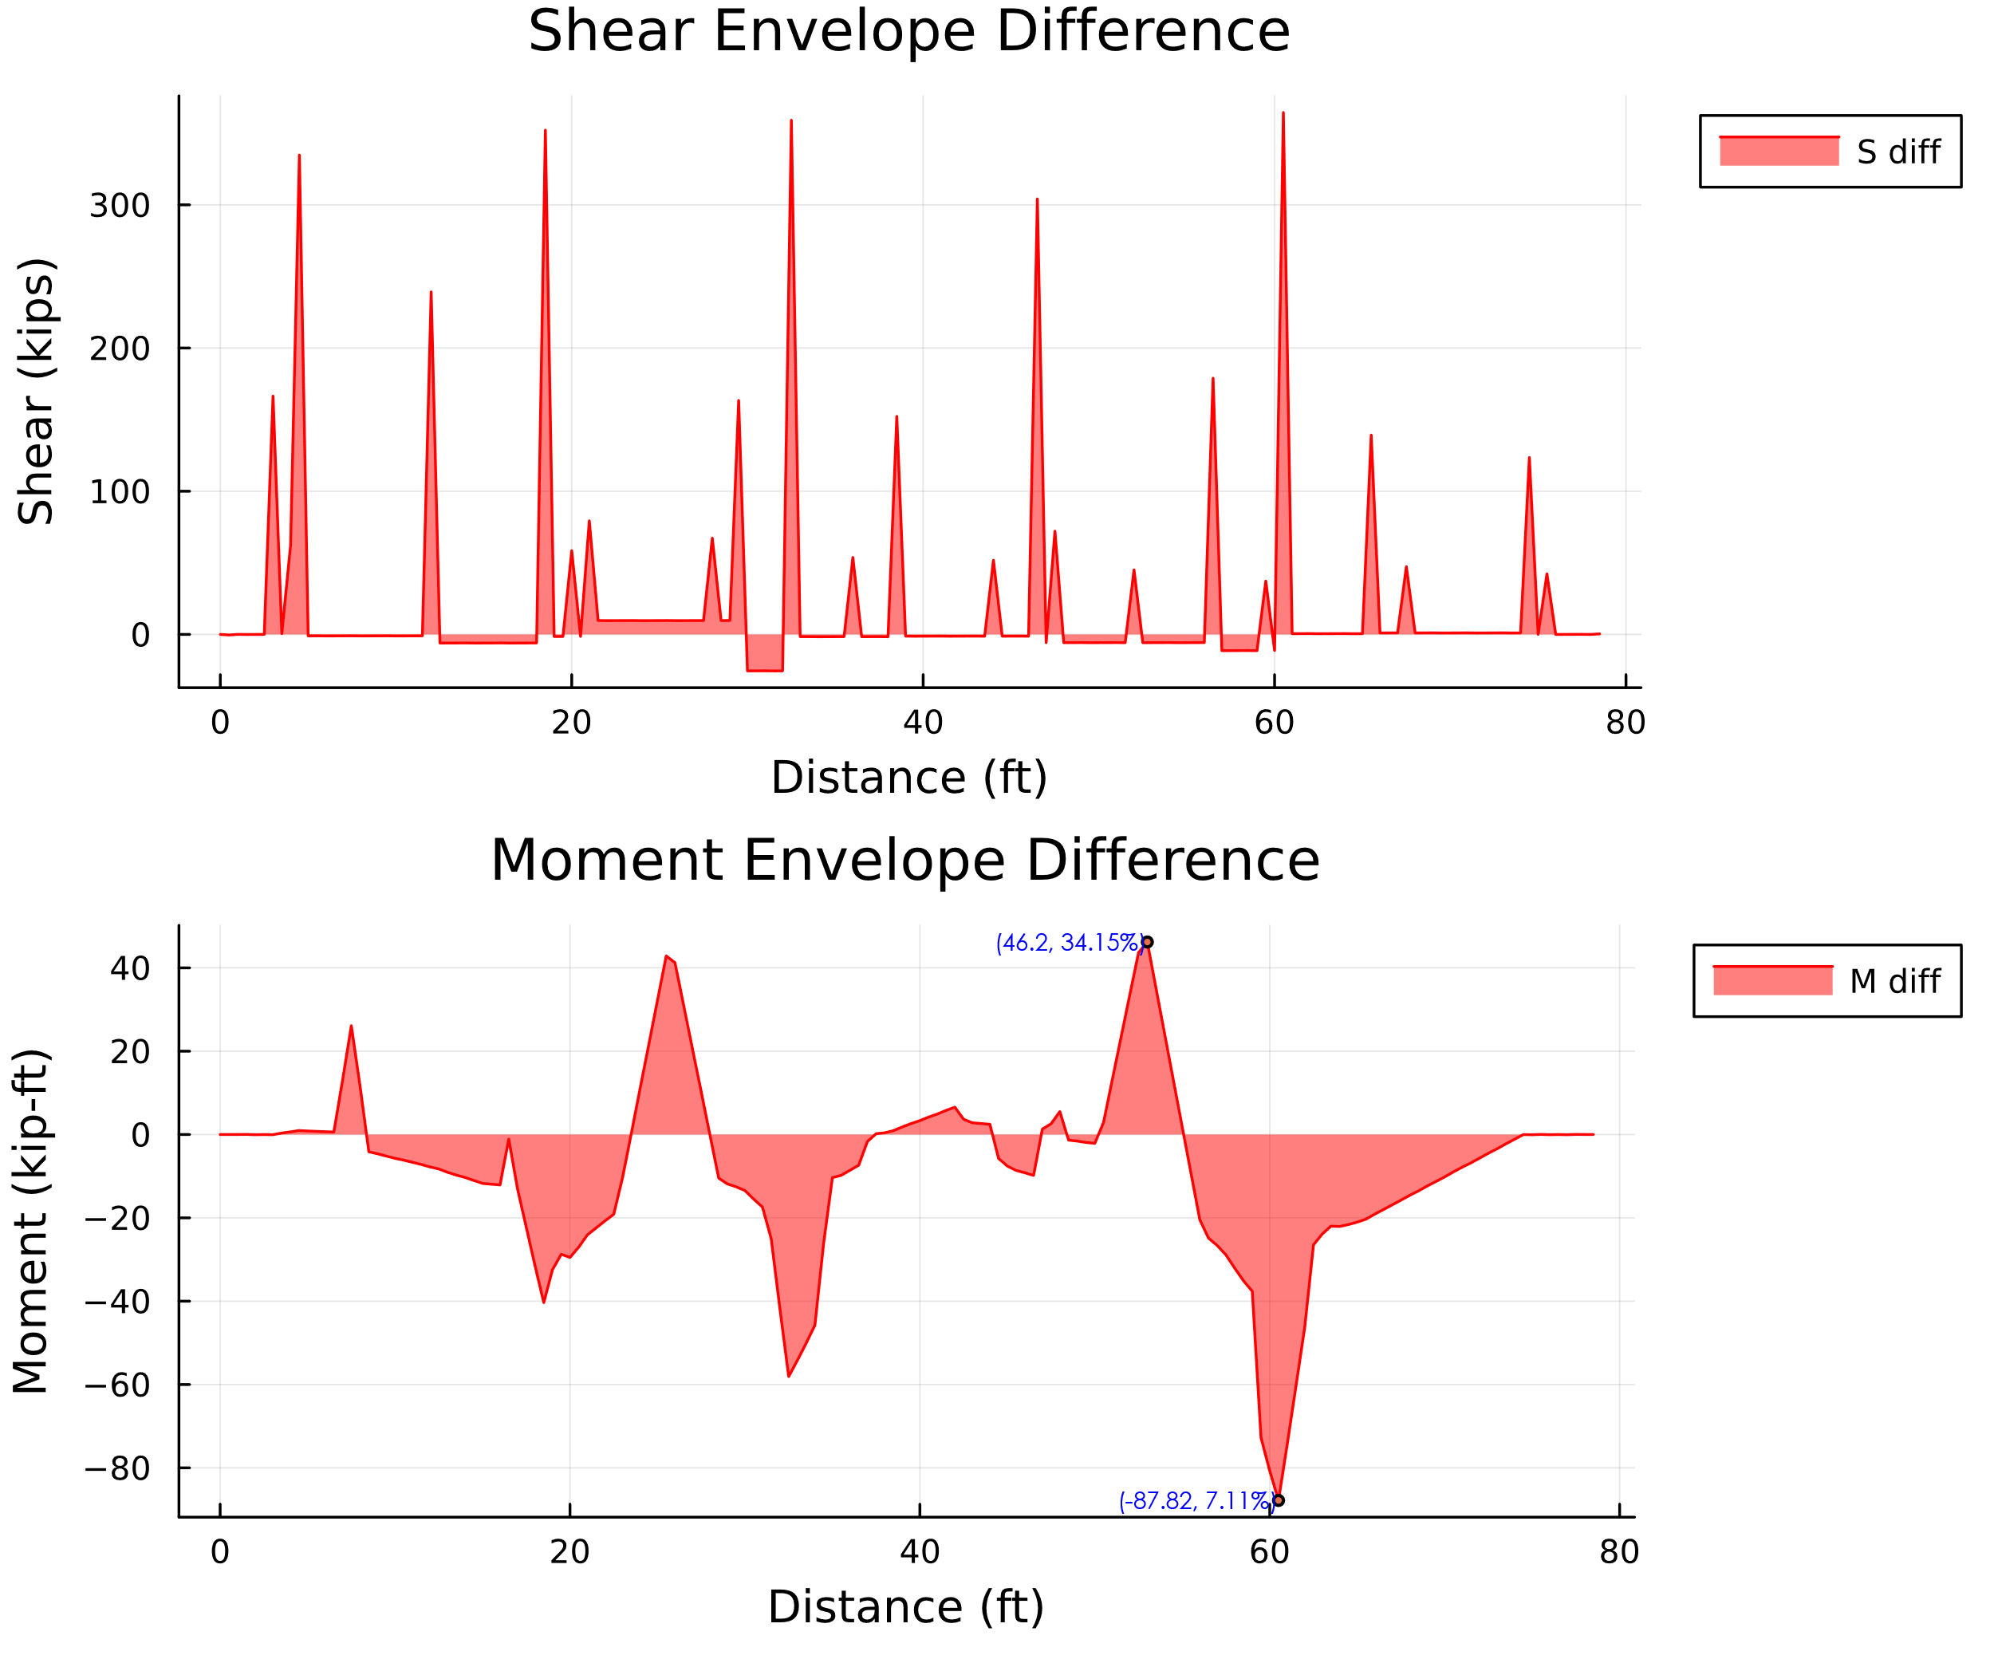

1. Comparison: Strength Shear and Moment Min Envelope Difference

### Live Load Comparison (STR)

The figures below compare the load factor results for the maximum stress envelope of the live load between the two programs. The areas in red highlight where larsa results were greater in magnitude than the cap18 results. There are some visible red areas in the shear diagram. However, these can be explained by the difference in point load modeling between the two programs. The maximum values are shown to be very similar. In areas of maximum moment, the results are within 3% (when looking at the positive moments).

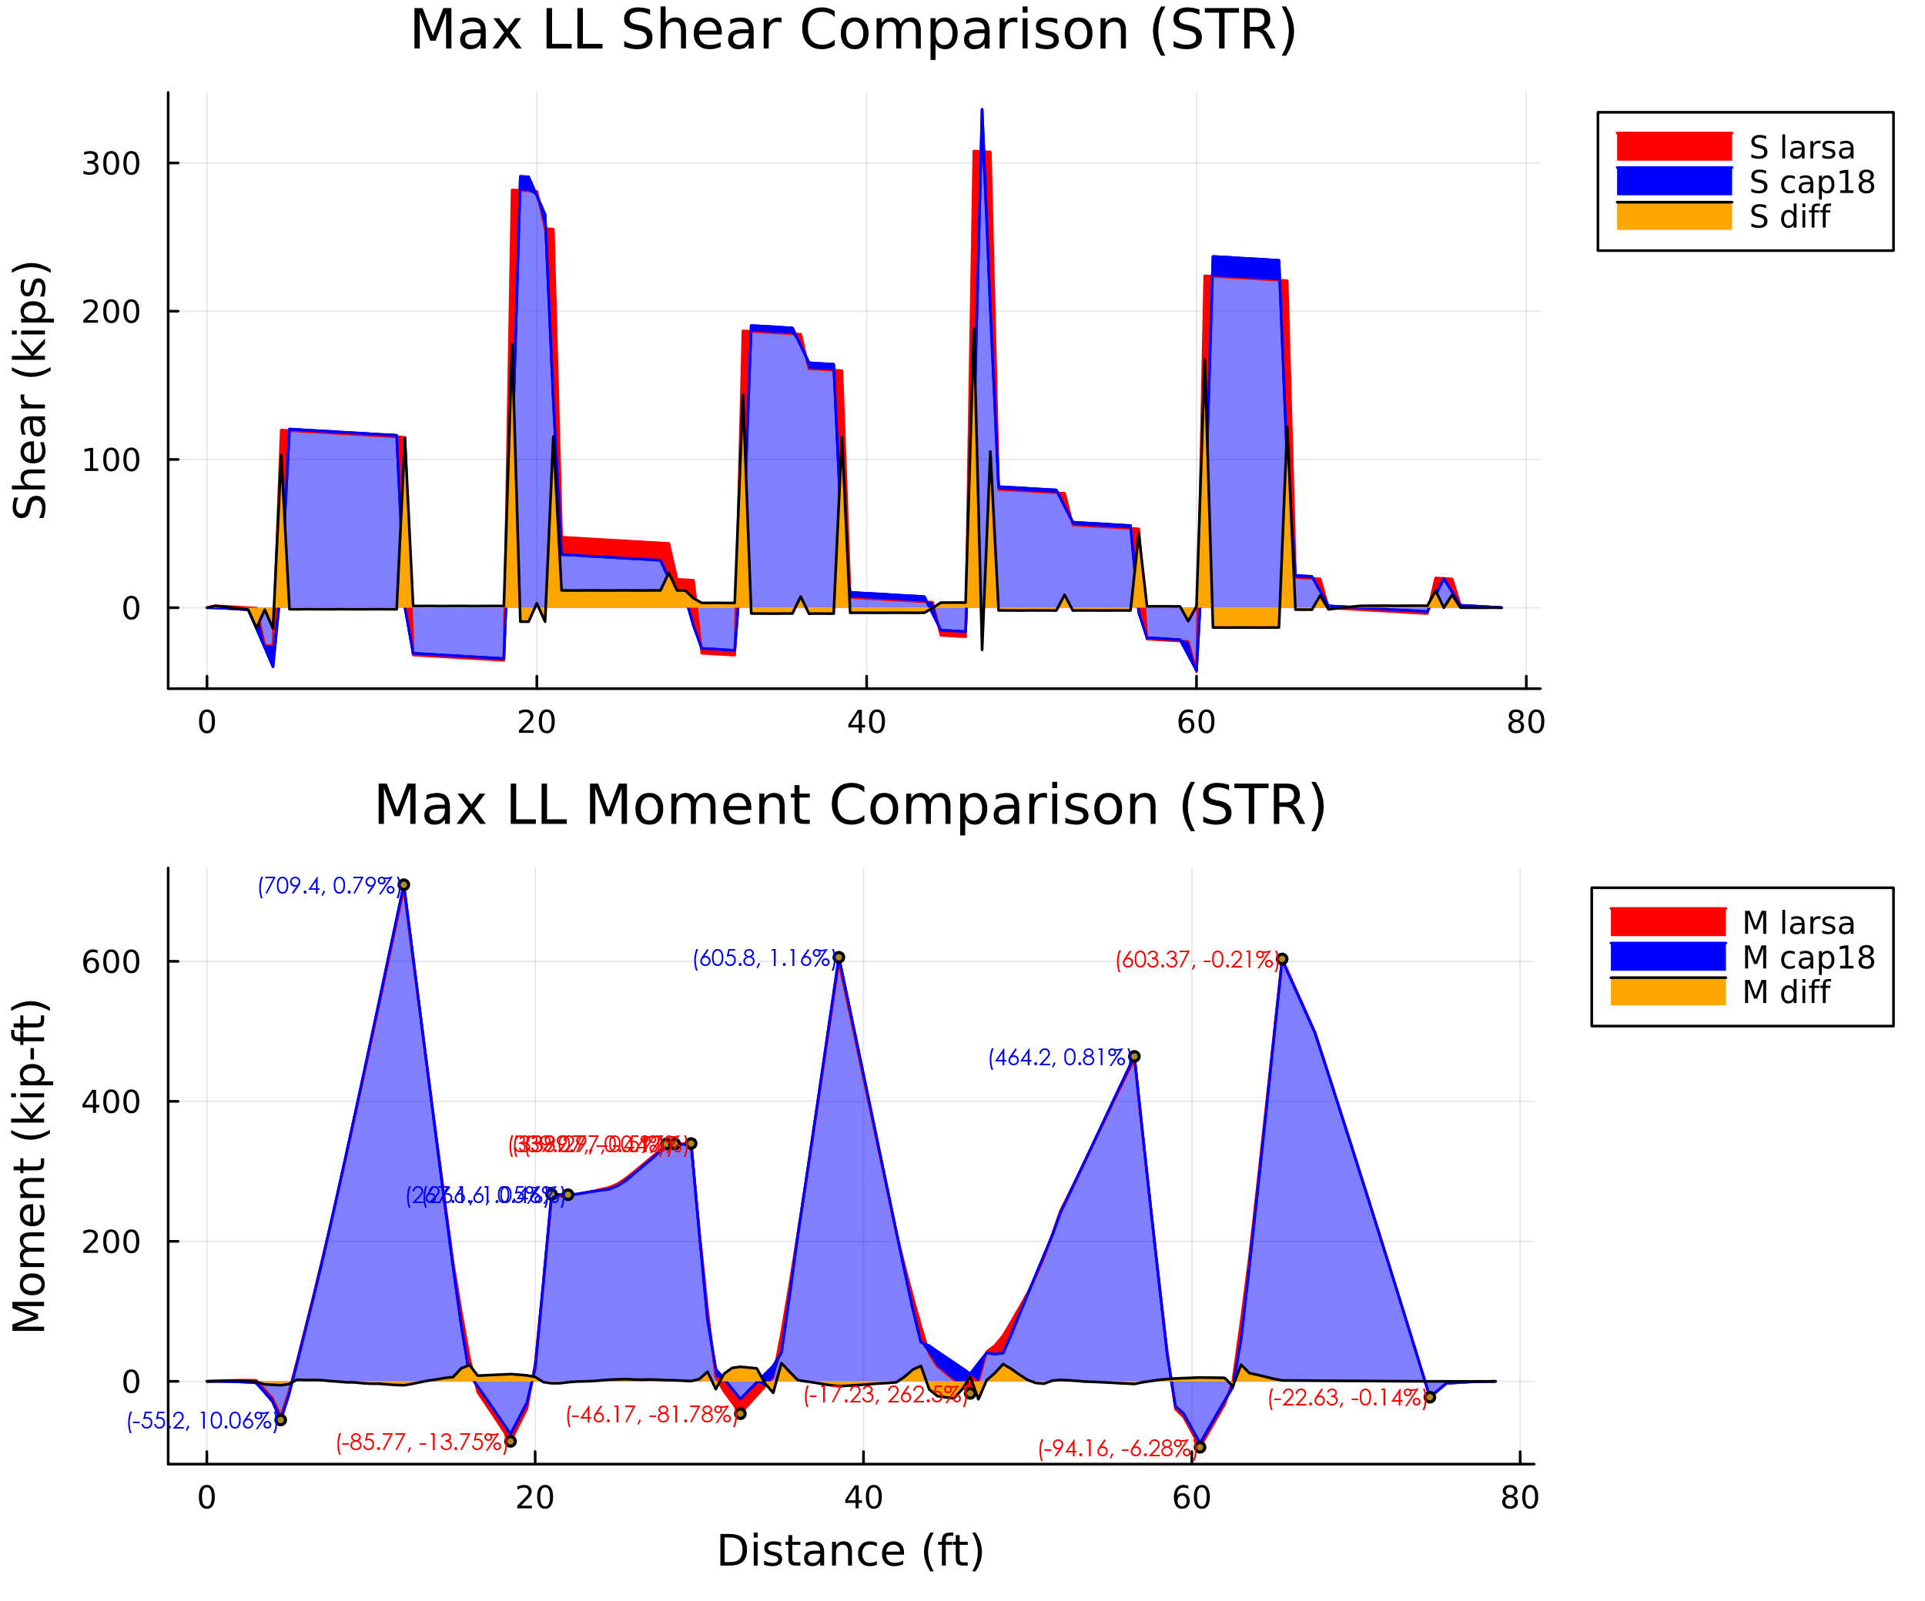

1. Comparison: Strength Shear and Moment Max LL Envelope Diagrams

The figures below compare the load factor results for the minimum stress envelope of the live load between the two programs. The areas in red (not the light red areas) highlight where larsa results were greater in magnitude than the cap18 results. There are some visible red areas in the shear diagram. However, these can be explained by the difference in point load modeling between the two programs. There are also large red spikes in the shear diagram for the larsa results. This is also a sign there are some unrealistic modeling behaviors in the larsa model.

The maximum moment values are shown to be very similar. In areas of maximum moment, the results are greater at 11%. However, with the limitations of the larsa model, this is not alarming. Cap18 results are higher and the program is doing a better job at maximizing the controlling areas.

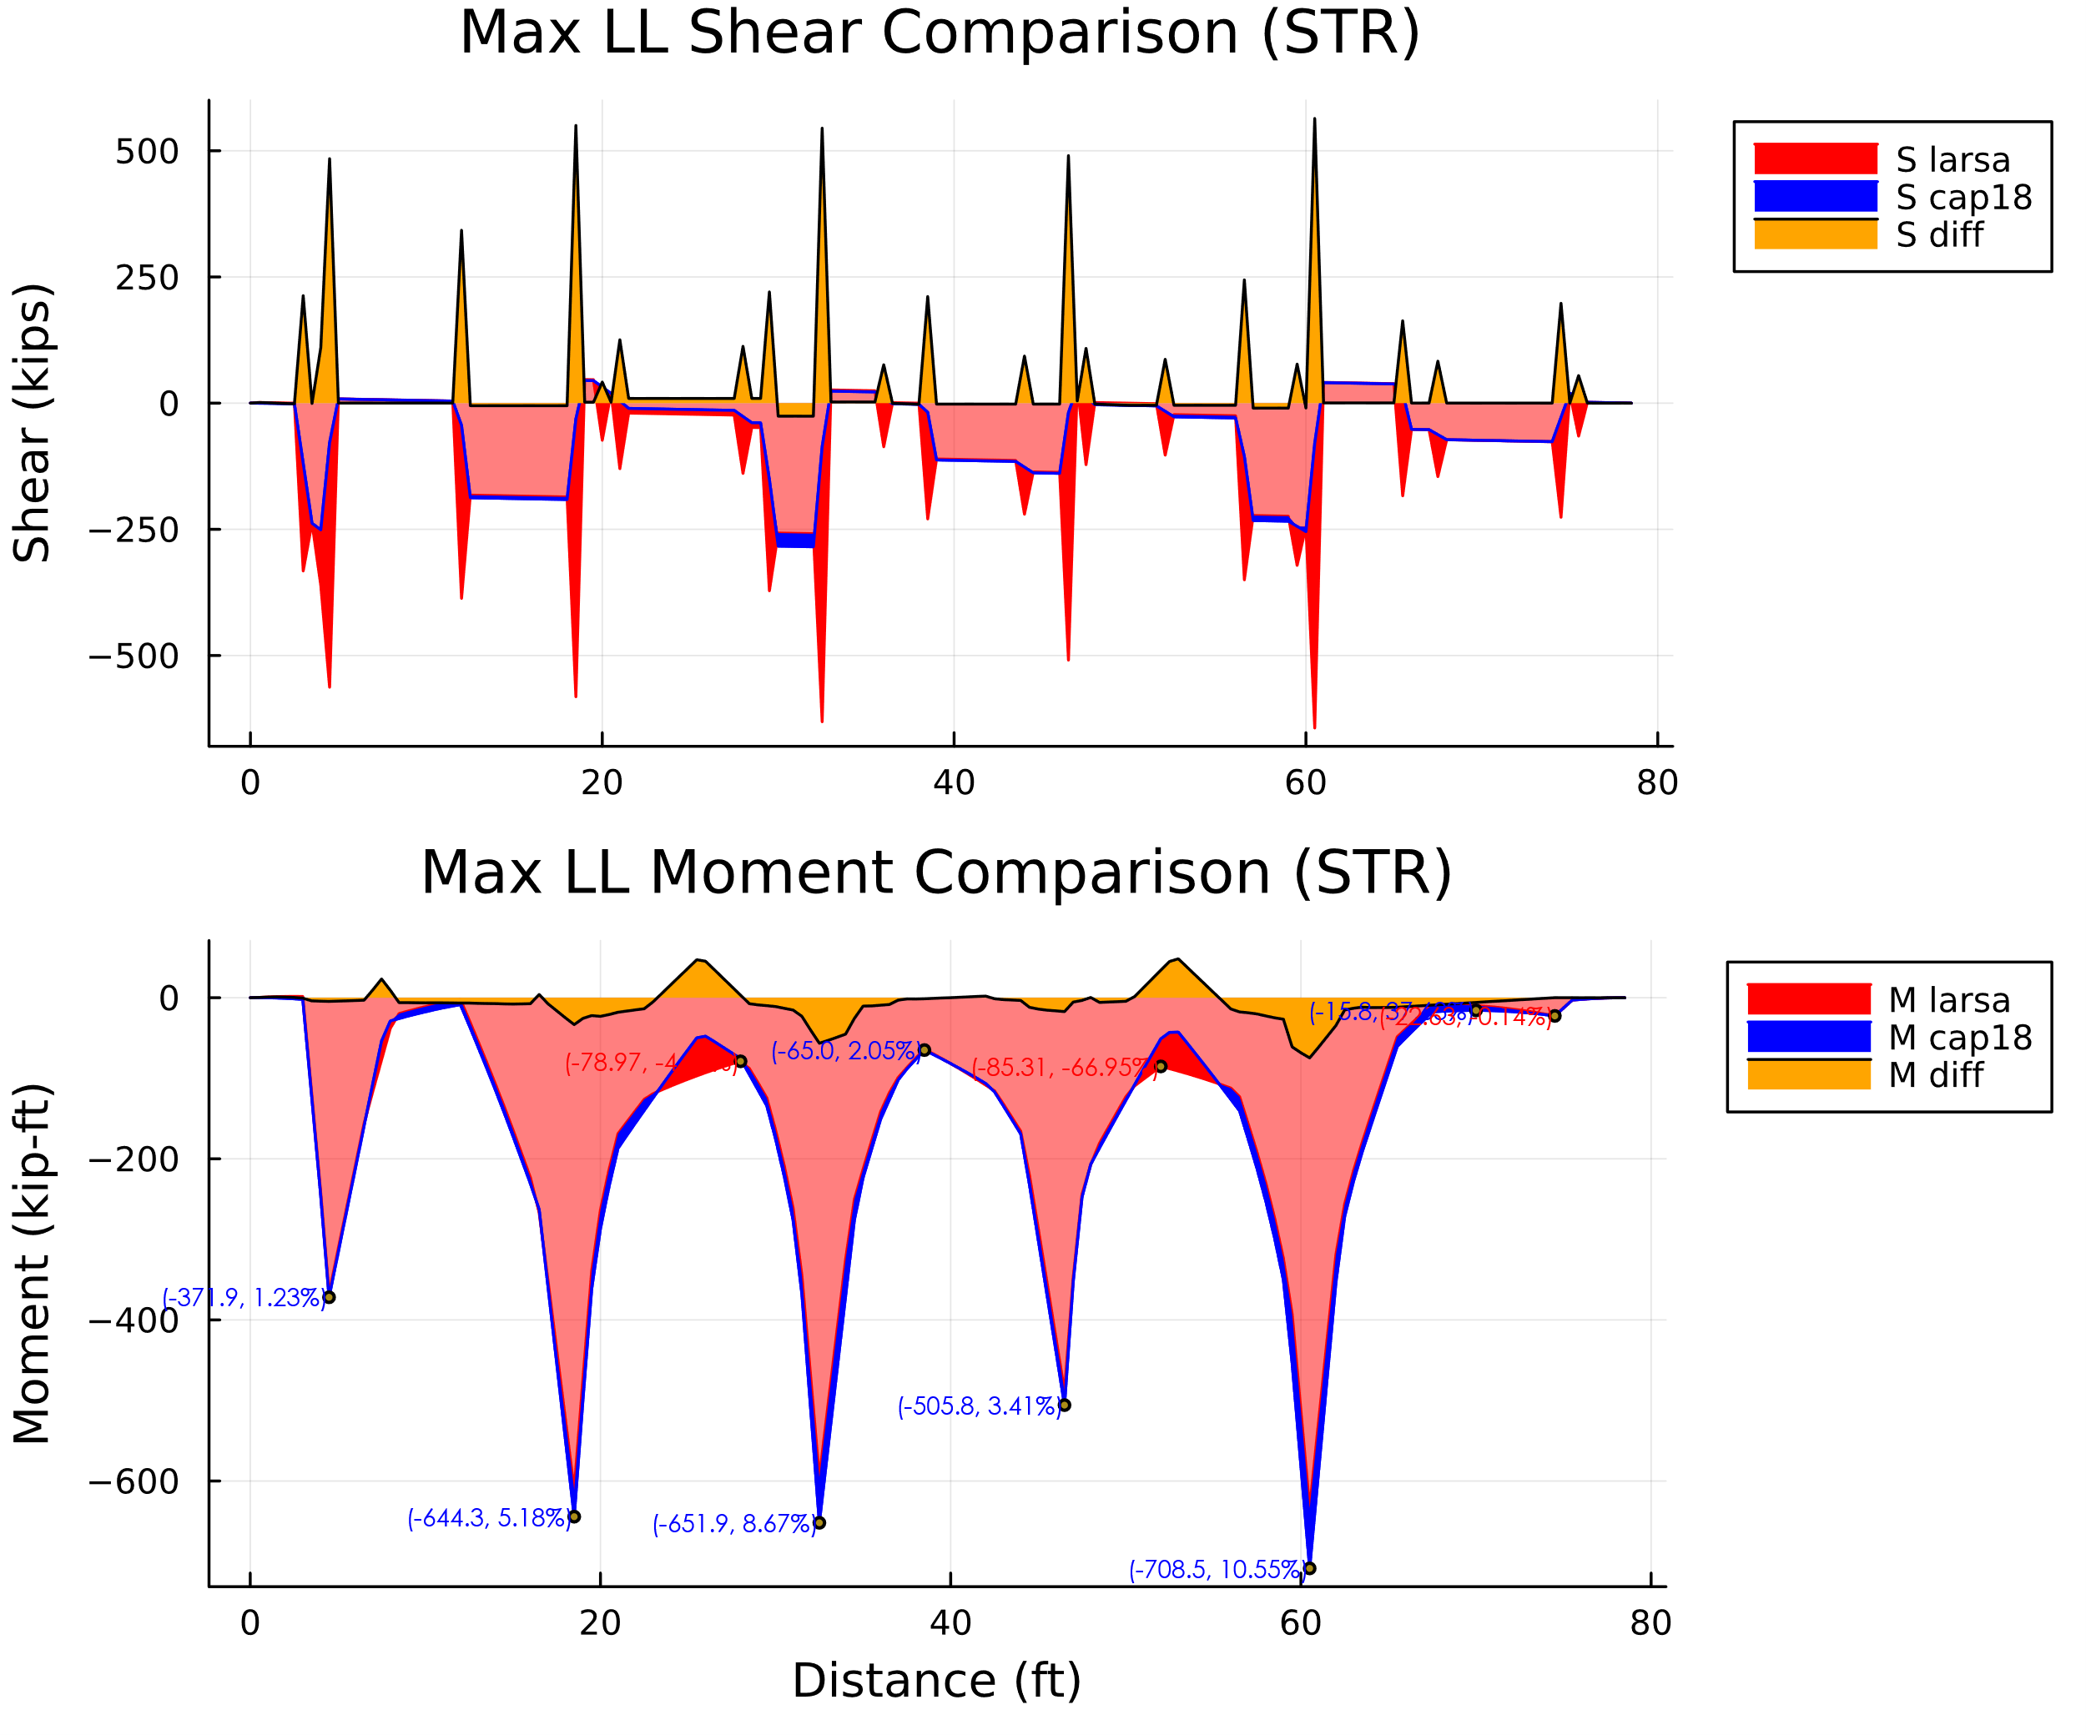

1. Comparison: Strength Shear and Moment Min LL Envelope Diagrams

### Maximum Support Reactions (STR)

The figure below compares the load factor results for the maximum and minimum reactions between the two programs. The results between programs are within 5% of eachother.

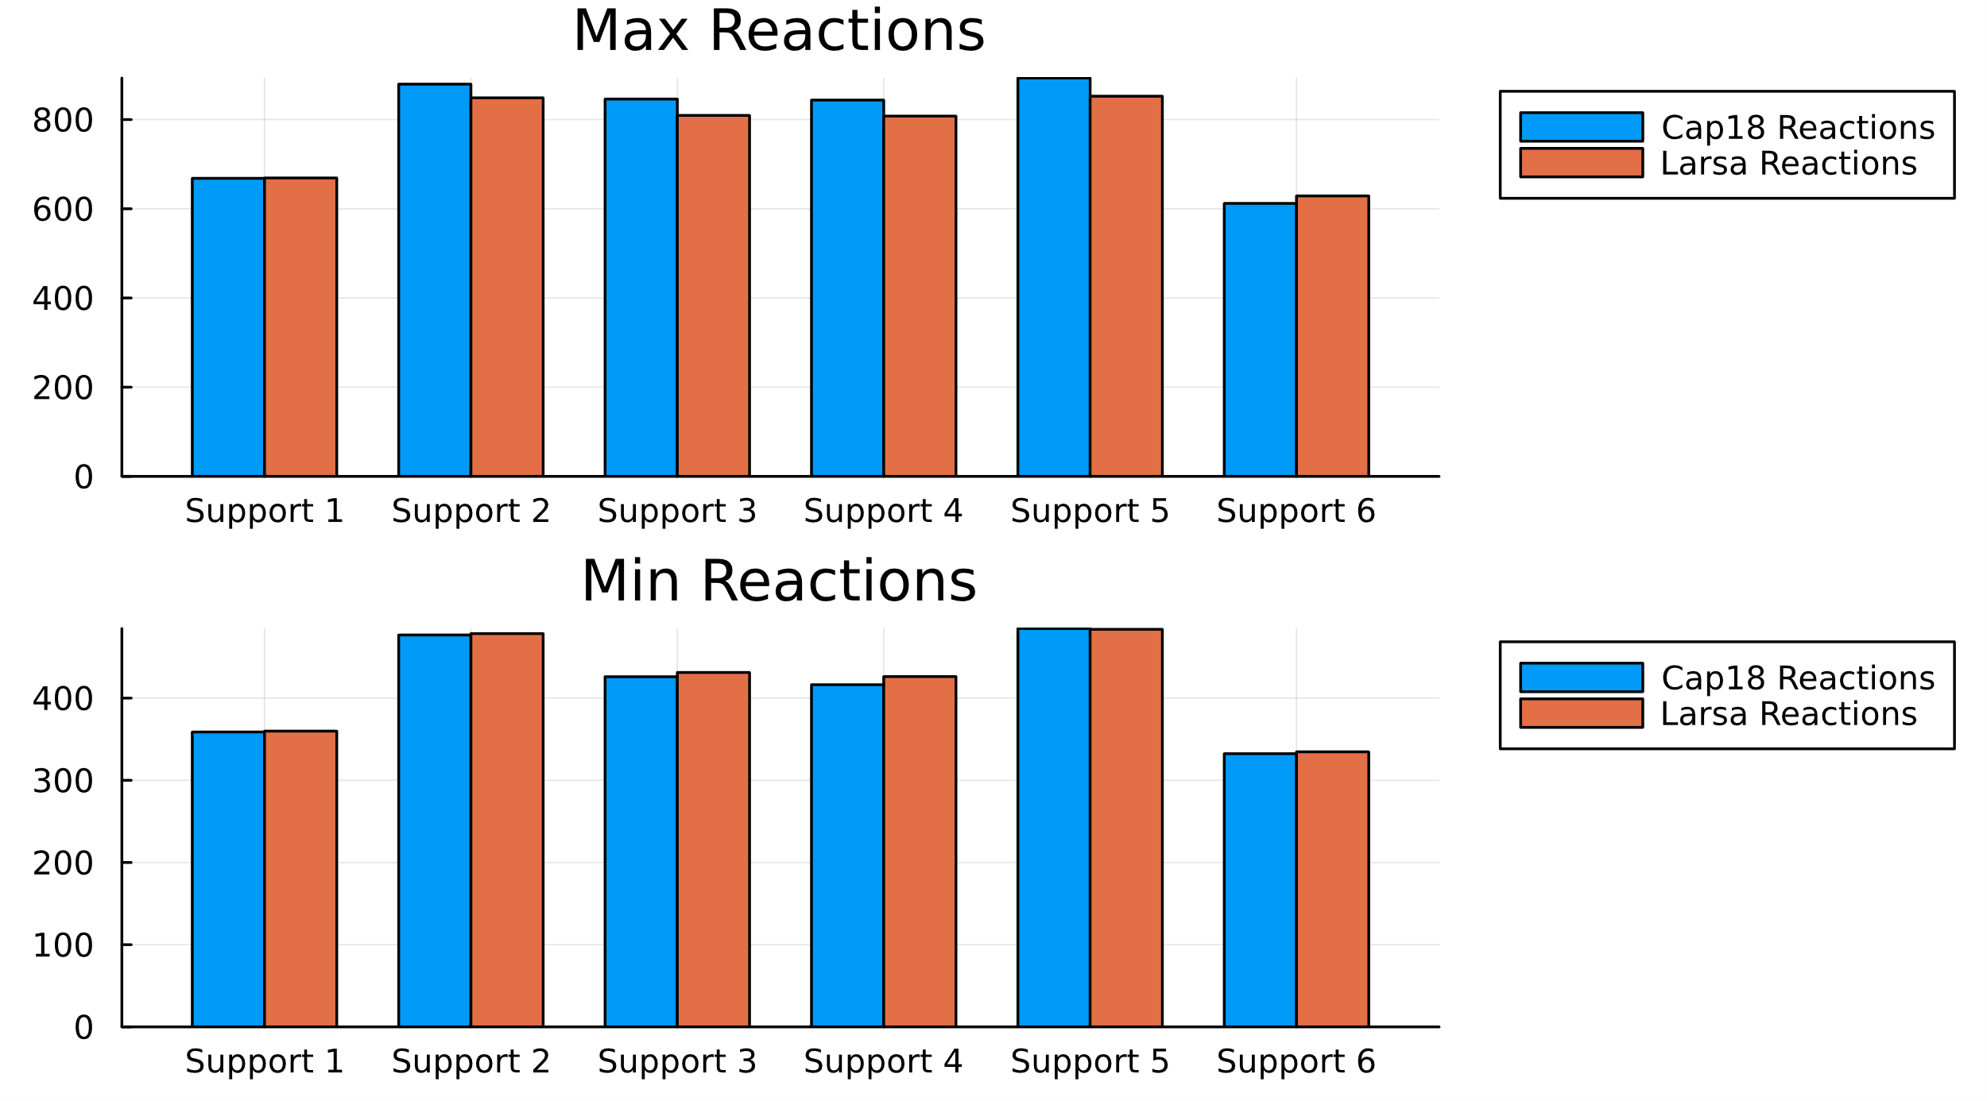

1. Comparison: Strength Reactions